Electronic Cataloging
(E-Cat) Procedures Manual

April 2018

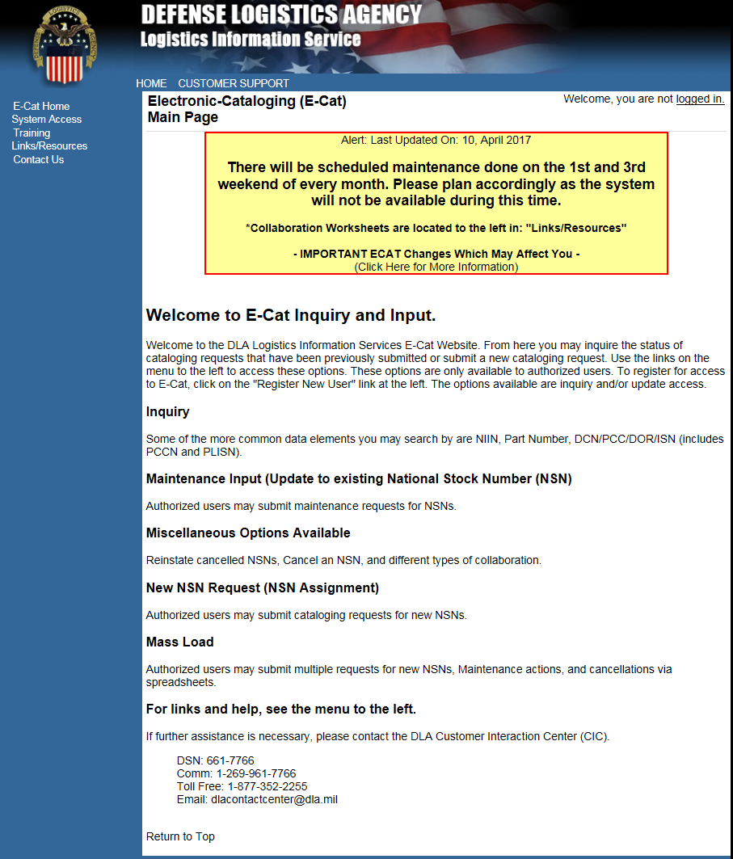
Be sure to read E-Cat banner! Important information displays here.

Table of Contents
1. Introduction 1
2. System Access 1
2.1 Registration Information 1
2.2 Training 2
3. Inquiry 3
4. Inquiry Statistics 5
5. General Cataloging Request Information 7
5.1 Attachments 8
5.2 Characteristics 9
5.3 Supporting Technical Documentation (Top right of page) 9
5.4 Special Processing/Additional Information 9
5.5 Collaboration Input 10
5.6 Cancel an NSN Input 11
6. Unique Input for U.S. Customers 13
6.1 New NSN Assignment and Reinstate a Cancelled NSN 13
6.1.1 New NSN Assignment Pop-up 14
6.1.2 Reinstate a Cancelled NSN Pop-up 14
6.1.3 New Item and Reinstatement Input Form 14
6.1.4 Item Identification Data 15
6.1.5 User Data 16
6.1.6 Reference Data 17
6.1.7 Standardization Data 17
6.1.8 Management Data 18
6.1.9 Support Data 21
6.2 Update an Existing NSN 22
6.2.1 Action Indicators 23
6.2.2 Standardization Data 24
6.3 Item Entry Control Review 27
6.4 Freight 30
6.4.1 Freight Data Single Entry 30
6.4.2 Freight Data Mass Load 33
7. Unique Input for Non-U.S. Customers 35
7.1 New Item and Reinstatement Input Form 35
7.1.1 Item Identification Data 35
7.1.2 User Data 36
7.1.3 Reference Data 37
7.1.4 AC/135 No. 7 Form 37
7.2 Update an Existing NSN 38
7.2.1 Action Indicators 39
7.3 Submit Your Request 39
8. Mass Load Form 42
8.1 Step 1 Import 43
8.2 Step 2 Review Errors 47
8.3 Step 3 Load 48
8.4 Mass Load Notes 50
APPENDIX A – ACRONYMS 51

List of Figures
Figure 3 - 1. Inquiry Menu Option 3
Figure 3 - 2. Inquiry Search Criteria 3
Figure 3 - 3. Inquiry Results List 4
Figure 3 - 4. Detailed Search Results 5

Figure 5 - 1. Cataloging Requests Menu Option 7
Figure 5 - 2. Catagloging Requests Page 7
Figure 5 - 3. User Information Section 7
Figure 5 - 4. Attachments Field 8
Figure 5 - 5. Characteristics Field 9
Figure 5 - 6. Supporting Tech Documentation Field 9
Figure 5 - 7. Special Processing/Additional Information Field 9
Figure 5 - 8. Collaboration Page 10
Figure 5 - 9. Cancel an NSN Dialog box 11
Figure 5 - 10. Cancellation Page 12
Figure 5 - 11. Mass Load Form—Cancellation 13

Figure 6 - 1. New NSN Assignment Questions 14
Figure 6 - 2. Reinstate NSN Question 14
Figure 6 - 3. New Item Input Page 15
Figure 6 - 4. Item Identification Data—Definition Displayed 16
Figure 6 - 5. User Data Tab 16
Figure 6 - 6. Reference Data Tab 17
Figure 6 - 7. Standardization Data Tab 17
Figure 6 - 8. Add Standardization Data 18
Figure 6 - 9. Management Data Tab 19
Figure 6 - 10. Navy Management Control Data 19
Figure 6 - 11. USAF Management Control Data 19
Figure 6 - 12. Army Management Control Data 20
Figure 6 - 13. Marine Corps Management Control Data 20
Figure 6 - 14. SOCOM Management Control Data 20
Figure 6 - 15. Coast Guard Management Control Data 21
Figure 6 - 16. Support Data Tab 22
Figure 6 - 17. Update an Existing NSN Question 22
Figure 6 - 18. Update an Existing NSN—Marine Corps 23
Figure 6 - 19. Update an Existing NSN—Marine Corps Added Questions 23
Figure 6 - 20. Item Identification Data Tab 23
Figure 6 - 21. Type Action Indicators 24
Figure 6 - 22. Add Standardization Relationship 24
Figure 6 - 23. Change Standardization Relationship 25
Figure 6 - 24. Delete Standardization Relationship 26
Figure 6 - 25. Change item Standardization Code 27
Figure 6 - 30. Item Entry Control Question 27
Figure 6 - 31. Item Entry Control Review Single Input Form 28
Figure 6 - 32. E-Cat Item Entry Mass Load Form 29
Figure 6 - 33. Freight Data Input Dialog Box 30
Figure 6 - 34. Freight Data Page 30
Figure 6 - 35. Freight Data Mass Load Dialog Box 30
Figure 6 - 36. Add New Freight Data 31
Figure 6 - 37. Change Current Freight Data 32
Figure 6 - 38. Challenge Freight Data 33
Figure 6 - 39. Freight Mass Load Add or Change 34
Figure 6 - 40. Freight Challenge Mass Load 34

Figure 7 - 1. Item Identification Data—Definition Displayed (Non-U.S. Customer) 36
Figure 7 - 2. User Data Tab (Non-U.S. Customer) 36
Figure 7 - 3. Reference Data Tab (Non-U.S. Customer) 37
Figure 7 - 4. AC/135 No 7 Form (Non-U.S. Customer) 38
Figure 7 - 5. Item identification Data (Non-U.S. Customer) 38
Figure 7 - 6. User Data Action Indicators (Non-U.S. Customer) 39
Figure 7 - 7. Reference Data Tab (Non-U.S. Customer) 39
Figure 7 - 8. Show Results Confirmation Page 40
Figure 7 - 9. Show Results Confirmation Page (continued) 41

Figure 8 - 1. Mass Load Form 42
Figure 8 - 2. Excel Spreadsheet for Import 43
Figure 8 - 3. Select Elements for Import 43
Figure 8 - 4. Elements Selected—Columns Identified 44
Figure 8 - 5. Import Spreadsheet Dialog Box 44
Figure 8 - 6. File Imported 45
Figure 8 - 7. View Imported File 45
Figure 8 - 8. Apply Mappings 46
Figure 8 - 9. Invalid Field Indicator 46
Figure 8 - 10. Review Errors 47
Figure 8 - 11. No Errors Found 48
Figure 8 - 12. Supporting Documents Added 49
Figure 8 - 13. Special Processing/Additional Information Field 49
Figure 8 - 14. Mass Load Successful Message 50

List of Tables
Table 3 - 1. Inquiry Format Guidelines 4
Table 5 - 1. Cataloging Requests page Elements 8
Table 5 - 2. Collaboration Form Elements 11
Table 5 - 3. Cancellation Page Data Elements 12

Introduction
Electronic Cataloging (E-Cat) Web application is intended for use by DLA Logistics Information Services personnel and their customers at various Inventory Control Points, the offices or agencies that manage supply items. Users can query and display cataloging request records in the FLIS Portfolio Workbench (FPW) database. Outside of a system-to-system interface, E-Cat is the only method for authorized users to manually submit new requests for catalog action.

System Access
Access E-Cat at: https://www.logisticsinformationservice.dla.mil/ecat/Default.aspx. To register for E-Cat, from the home page, select System Access and click Register for E-Cat.

Registration Information
Users register for E-Cat through the Account Management and Provisioning System (AMPS).
- Click on Register for E-Cat. A Windows Security Select a Certificate window opens.
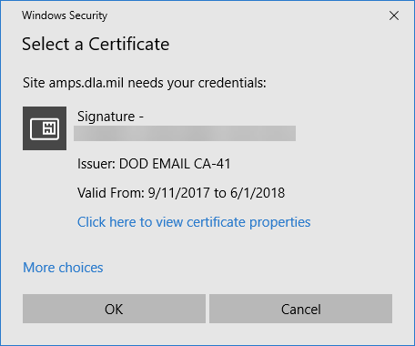
Figure 2 - 1. Select a Certificate
- Select your email certificate and click OK to open the AMPS Gateway.
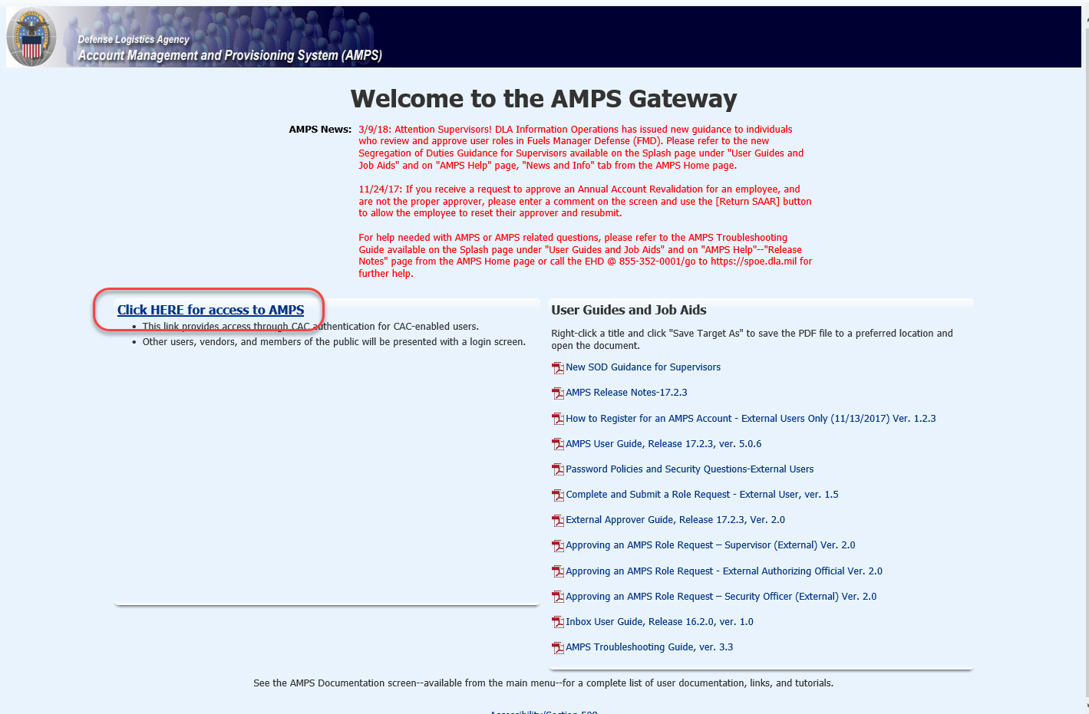
Figure 2 - 2. Welcome to the AMPS Gateway
- Click on Click HERE for access to AMPS. See the AMPS documentation on the AMPS website for help using AMPS.
  - E-Cataloging is listed under DLA Information Services Applications.
  - Choose options as needed:
    - E-Cataloging PROD – ECAT-002 CT/UP to allow you to input Cataloging transactions
    - E-Cataloging PROD – ECAT-001 CT/IQ to allow you to inquiry only on previous inputs.

Training
Training can be conducted by site visit or Webinar. Please contact the Training Branch by one of the following methods:
- https://www.logisticsinformationservice.dla.mil/training/request/
- Email: dla.tng@dla.mil
- Phone 269-961-4829 (COM) 312-661-4829 (DSN)

Inquiry
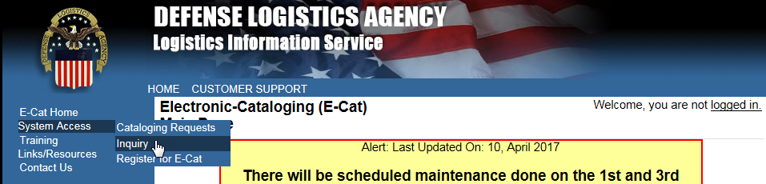
Figure 3 - 1. Inquiry Menu Option
Access the E-Cat Inquiry function by clicking on System Access and then Inquiry. This function allows you to search by certain data elements and view detailed information about the requests returned in the search.
Figure 3 - 2. Inquiry Search Criteria
- Select the item to search by from the drop-down list. You can only choose one value at a time from the following options:
  - Action ID
  - Contact Name
  - Control Number
  - DOR
  - ISN
  - Part Number
  - PCC
  - PCCN (Provisioning Contact Control Number)
  - PLISN (Provisioning Line Item Serial Number)
  - DCSN (Document Control Serial Number--last 7 chars of DCN
  - NIIN (National Item Identifier Number)
  - NICN (Navy Item Control Number)

- Enter value to search for in “Inquiry” field. Format guidelines for each search data element are shown in Table 1.

Item to Search By | Number of Characters
Action ID | Up to 8
Contact Name | Up to 50
Control Number | Up to 35
DOR | Up to 4
DCSN (last 7 chars of DCN) | Exactly 7
ISN | Up to 6
NIIN/NICN | Up to 9
Part Number | Up to 500
PCC | Up to 3
PCCN | Up to 6
PLISN | Up to 8
Table 3 - 1. Inquiry Format Guidelines
- Select the number of results from the inquiry that you want displayed on the page, from 10 to 50. This selection only limits the way you view the results and does not restrict the number of matches returned.
- Click the Search button. (The Reset button clears your selections for a new search.)
- The results of the search are listed on the Inquiry Results List.

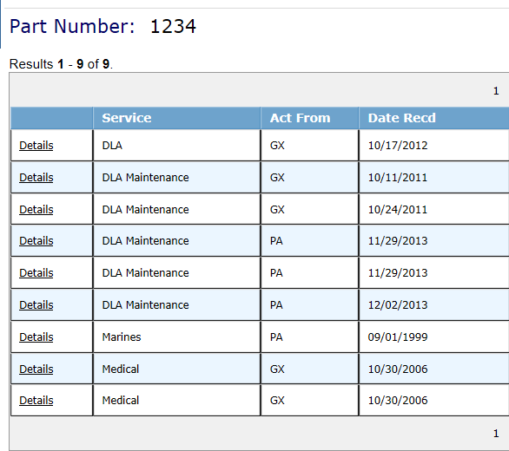
Figure 3 - 3. Inquiry Results List
- When multiple matches are found, Inquiry results are listed in a table on the page.
- Column headings are clickable for sorting the results in ascending or descending order.
- Use the New Search link at the bottom of the results page to perform a new inquiry.
- Click the Details link of an item to see view-only details of that item on the Detailed Search Results page.
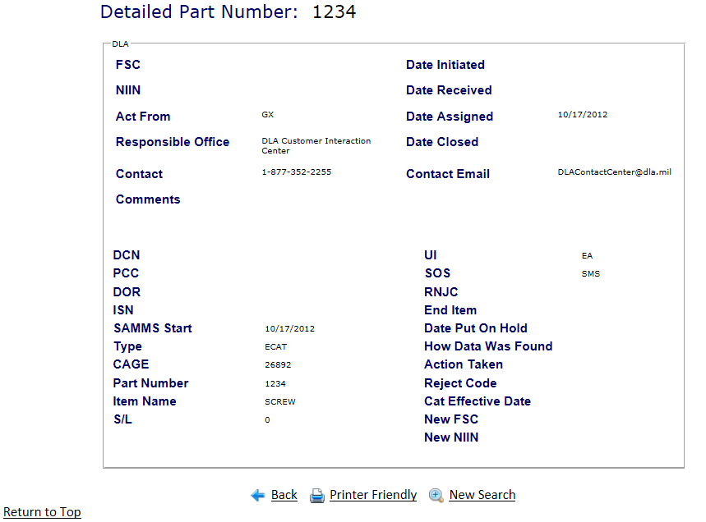
Figure 3 - 4. Detailed Search Results
- Click the New Search link at the bottom of the page to perform another inquiry.
- The Back link returns to the previous page.

Inquiry Statistics
This inquiry provides the number of inquiries processed by a specified date range.
- Click the Inquiry Statistics link at the bottom of the Inquiry page to open the Inquiry Statistics page.
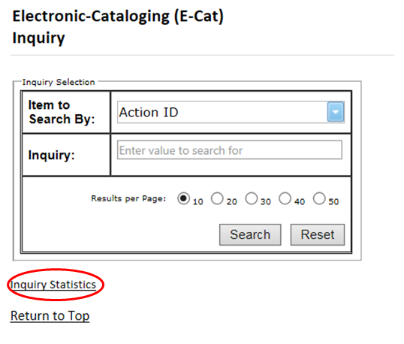
Figure 4 - 1. Inquiry Statistics Page
- Enter a start date and an end date in mm/dd/yyyy format.
- Click Run Statistics.
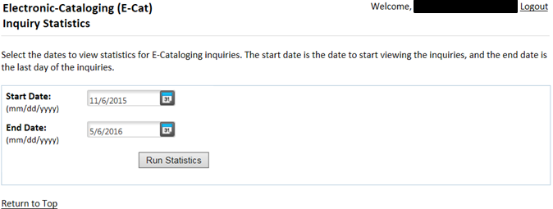
Figure 4 - 2. Run Statistics
Results are then listed at the bottom of the same page.
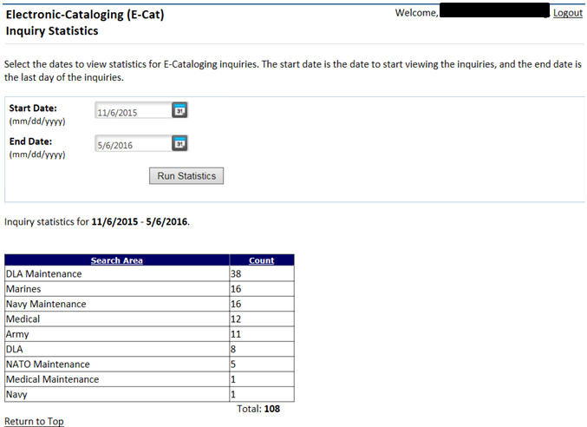
Figure 4 - 3. Run Statistics Results
- Column Headings: Search Area and Count are clickable to sort the results.
- You can change the dates and re-run as needed.

General Cataloging Request Information
All data elements/fields identified with an ‘*’ are mandatory values.

The Cataloging Requests menu option is the launch page for all E-Cat forms.
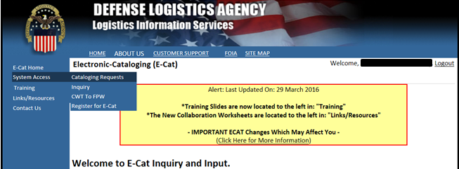
Figure 5 - 1. Cataloging Requests Menu Option
Select Cataloging Requests from the System Access menu. The Cataloging Requests page displays.
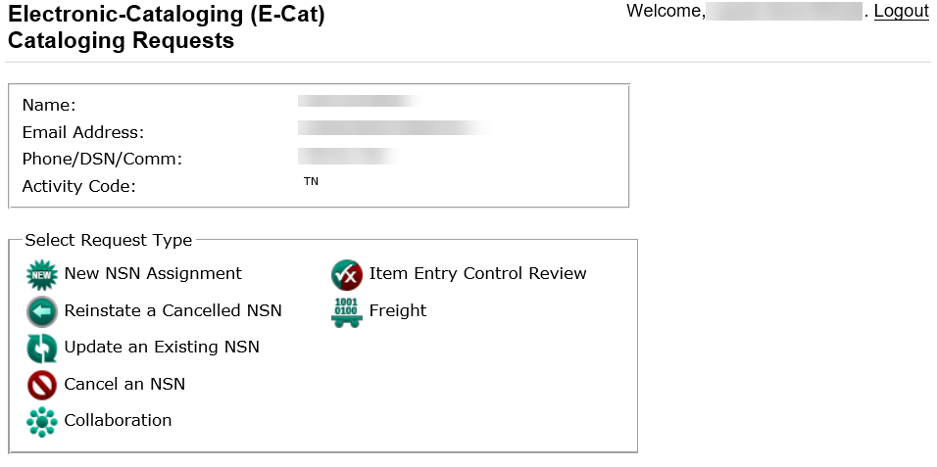
Figure 5 - 2. Cataloging Requests Page
The user information section will appear differently for Logistics Information Service users (Activity Code 98) as seen below. Non-U.S. users will see this form, but the Submitting Activity Code will be auto-populated and not editable as shown above.
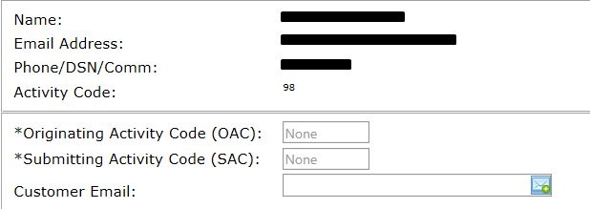
Figure 5 - 3. User Information Section
The elements of the Cataloging Requests page are described in Table 5-1.
Element | Characteristics
Name | Auto populated from account registration and cannot be changed
Email Address | Auto populated from account registration and cannot be changed. This field is manually entered by Activity Code 98 users when a customer email notification is required.
Phone/DSN/Comm | Auto populated from account registration and cannot be changed
Activity Code | Auto populated from account registration and cannot be changed
Originating Activity Code (OAC) | Max length 2 and visible to activity 98 and North Atlantic Treaty Organization (NATO) users
Submitting Activity Code (SAC) | Max length 2 and visible to activity code 98 and NATO users
Customer Email | Max length 50 and visible to activity 98
Request Type Pick List | New NSN Assignment  Reinstate a Cancelled NSN  Update an Existing NSN  Cancel an NSN  Collaboration  Item Entry Control Review  Freight
Table 5 - 1. Cataloging Requests page Elements

Attachments
This field is available within all input screens. You can add up to three supporting documents. An individual file can be no larger than 4 MB, and the total attachments can be no greater than 12 MB. Excel spreadsheets are prohibited.
    - Click on the Browse… button.
    - Choose a file to upload from your computer.
    - Select the Open button.
    - The file is added.
To remove the attachment, click on the Delete icon to the left of the file name.
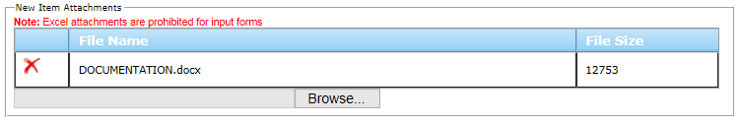
Figure 5 - 4. Attachments Field

Characteristics
This field is displayed for New NSN Assignment, Reinstate a Cancelled NSN, and Update Existing NSN request types. It is optional for all requests. Enter a description of the characteristics in the provided text box, with a maximum of 1,499 characters.
Figure 5 - 5. Characteristics Field

Supporting Technical Documentation (Top right of page)
This field is displayed for New NSN Assignment, Reinstate a Cancelled NSN, Update Existing NSN and Item Entry Control Review request types. It is mandatory for New NSN Assignment and Reinstate a Cancelled NSN, and optional for Update an Existing NSN and Item Entry Control Review.
    - If your supporting technical documentation is available in a repository, use the drop-down list to select that location.
    - If you are attaching the supporting technical documentation to this request, select the Attached check box. If selected, an attachment must be present when you submit the request.
    - If you added the location in the Special Processing/Additional Information field, select the See Special Processing/Additional Information check box. If selected, text must be present in the Special Processing/Additional Information field when you submit the request.
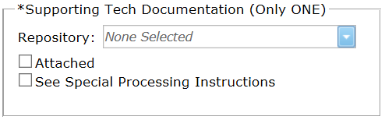
Figure 5 - 6. Supporting Tech Documentation Field

Special Processing/Additional Information
This field is available on all input screens. If you wish to add comments or special instructions for the item, use this text box. This text box has a maximum of 1,499 characters.
Figure 5 - 7. Special Processing/Additional Information Field

Collaboration Input
Collaboration JLC Worksheets and Instructions are available on the home page under Links/Resources.
    - Non-consumable Item Material Support Request Worksheet (replaced JLC 17)
    - PICA/SICA Management Level Change and/or Reassignment Request (replaced JLC 19)
When Collaboration is selected from the E-Cat Request page, the Collaboration page opens. Each form/worksheet will have a hyperlink to the form/worksheet selected.
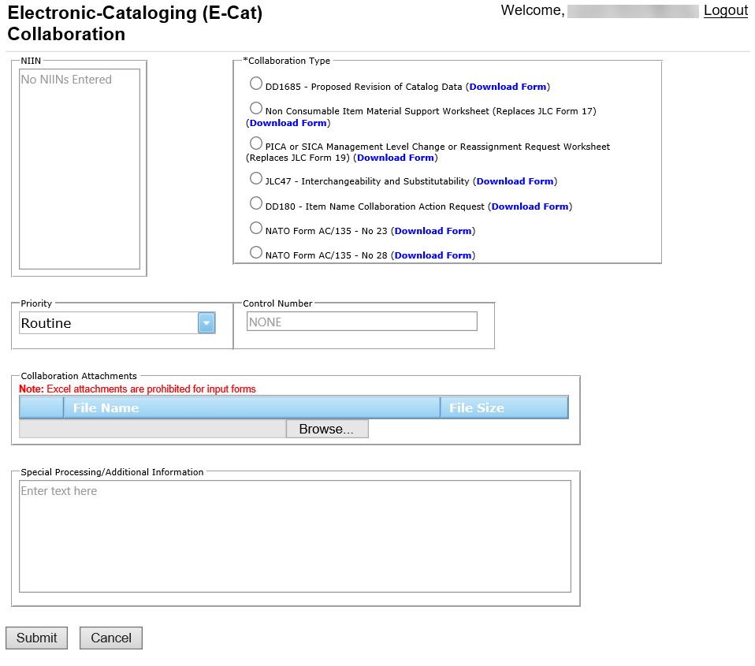
Figure 5 - 8. Collaboration Page
The Collaboration form has the following data elements:
Element | Characteristics
NIIN | Mandatory 9-digit field. Enter one or more NIINs.
Collaboration Type | Mandatory: Click a radio button to select one of the following:  - DD1685 - Proposed Revision of Catalog Data. Not authorized for USMC customers. NIIN is mandatory.  - Non-consumable Item Material Support Request Worksheet. NIIN is mandatory.  - PICA or SICA Management Level Change or Reassignment Request Worksheet. NIIN is mandatory.  - JLC47 - Interchangeability and Substitutability. NIIN is mandatory.  - DD180 - Item Name Collaboration Action Request NIIN is not required.  - NATO Form AC/135 - No. 23 NIIN is mandatory.  - NATO Form AC/135 - No. 28 NIIN is not required.
Table 5 - 2. Collaboration Form Elements
    - Click the Submit button when satisfied with entries. If multiple NIINs are entered, E-Cat checks for duplicates.
    - When errors occur, messages are displayed at the top of the page. Correct errors and click Submit again until you see a success message Update successful at the top of the page.

Cancel an NSN Input
When Cancel an NSN is selected from the E-Cat Request page, a message displays asking if this will be a single input.
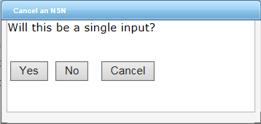
Figure 5 - 9. Cancel an NSN Dialog box
*If Yes, the Cancellation page opens.
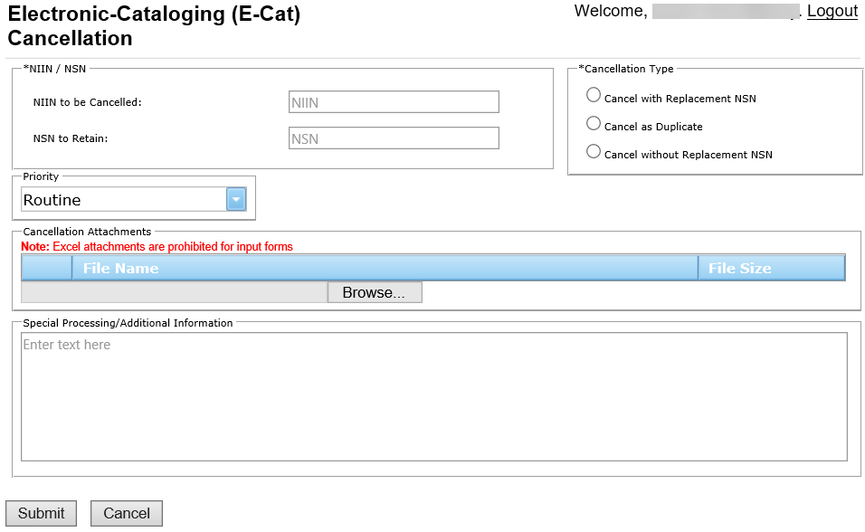
Figure 5 - 10. Cancellation Page
This form has the following data elements:
Element | Characteristics
NIIN to be Cancelled | Mandatory 9-digit field
NSN to Retain | Mandatory 13-digit field if Cancel with Replacement or Cancel as Duplicate is selected.
Cancellation Type | Choose one of the following:  - Cancel and Replace with new NSN  - Cancel as Duplicate  - Cancel without Replacement NSN
Table 5 - 3. Cancellation Page Data Elements
When all information is complete, click on the Submit button. A Save to FPW was successful message is displayed at the top of the page.

If you select No on the Cancel an NSN Dialog box, the Mass Load Cancellation page opens.
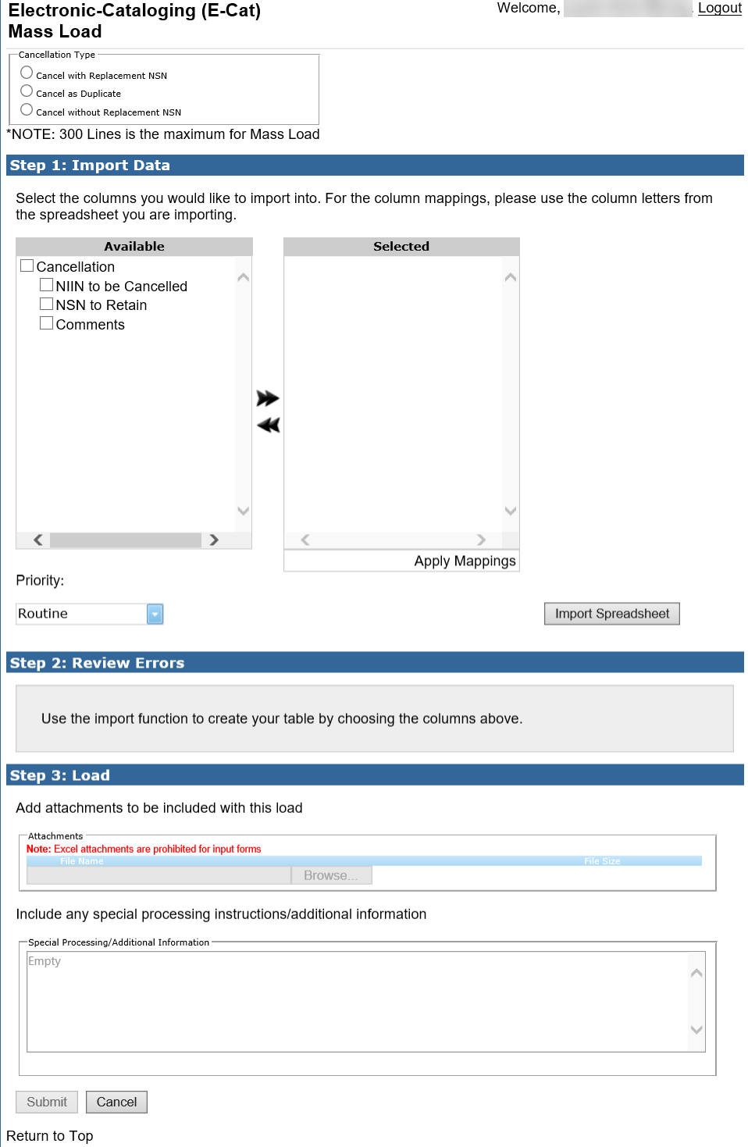
Figure 5 - 11. Mass Load Form—Cancellation
(See section 8.0 for further Mass Load instructions.)

Unique Input for U.S. Customers

New NSN Assignment and Reinstate a Cancelled NSN
Both request types generate pop-ups with questions designed to direct customers to forms with appropriate mandatory data elements. Mandatory fields for both request types are the same with the exception of NIIN. If the request type is Reinstate a Cancelled NSN the NIIN is mandatory.

New NSN Assignment Pop-up
Two questions are presented when the user selects New NSN Assignment: NSN DLA Managed? and Single Input?
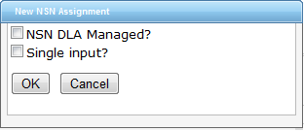
Figure 6 - 1. New NSN Assignment Questions
    - If the NSN is to be DLA managed, select the top check box.
    - Selecting the Single Input checkbox opens the single input page.
    - Leaving it unchecked opens the Mass Load form. (See section 8.0 for further Mass Load instructions.)
Note: United States Air Force (USAF) users should always select NSN DLA Managed. USAF managed new NSN assignment requests must be input into the USAF D143C System.

Reinstate a Cancelled NSN Pop-up
A question is presented when the user selects Reinstate a Cancelled NSN: Will the reinstated NSN be DLA managed?
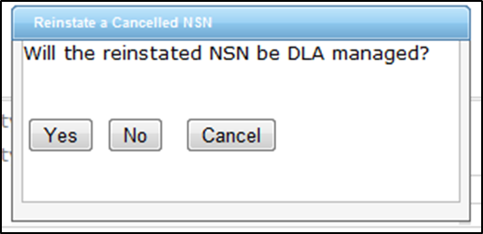
Figure 6 - 2. Reinstate NSN Question
If your activity code is 98, enter Originating Activity Code (OAC) (mandatory), Submitting Activity Code (SAC) (mandatory), and Customer Email (optional). Then select the New NSN Assignment request type from the pick list.
Note: USAF users may request reinstatement of an NSN that is DLA managed as well as AF managed NSNs which were cancelled in the Federal Logistics Information System (FLIS) via Cancel-Duplicate (LKD), Cancel-Use (LKU), and Cancel-Invalid (LKV) actions.

New Item and Reinstatement Input Form
The activity code information from your account registration auto populates at the top of the form.
Note: USAF new NSN assignment requests should only be submitted for DLA managed items. USAF managed new NSN requests must be input by the USAF into the AF D143C system in order for the USAF downstream systems to receive NSN data on USAF managed NSNs.
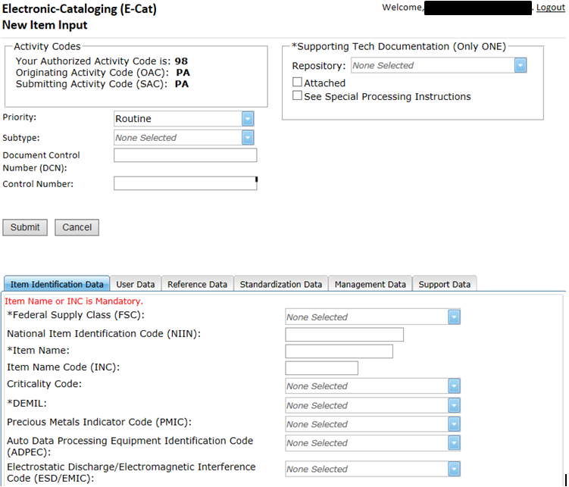
Figure 6 - 3. New Item Input Page
    - Priority - Default is Routine. The drop down allows you to indicate whether the request is Routine, Emergency, or Accelerated.
    - Subtype - This field may alter where the request is routed for catalog action so it should only be utilized when necessary.
    - Supporting Tech Documentation is mandatory.
The next section of the page contains information about the NSN. There are six tabbed sections: Item Identification Data, User Data, Reference Data, Standardization Data, Management and Support Data. Click on the tab to select each section.

Item Identification Data
The Item Identification Data section is displayed first. Enter all of the information that you have for the item. Data is mandatory depending on the type of request and the activity code of the user.
        - Federal Supply Class (FSC). If a specific FSC is unknown, the user can select the applicable general category that applies (displayed at the bottom of the drop down.)
        - National Item Identification Code (NIIN) (not used for New NSN Assignment)
        - Item Name (If the INC is blank or 77777, this field is mandatory.)
        - Item Name Code (INC) (mandatory if Item Name is blank)
        - Criticality Code
        - DEMIL
        - Precious Metals Indicator Code (PMIC)
        - Automatic Data Processing Equipment Identification Code (ADPEC)
        - Electrostatic Discharge/Electromagnetic Interference Code (ESD/EMIC)
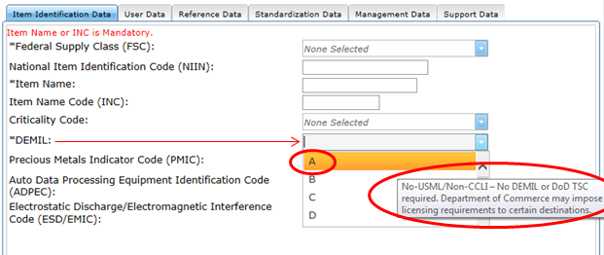
Figure 6 - 4. Item Identification Data—Definition Displayed
*If you hover over any value in a drop down, the definition is displayed.

User Data
Add user data information as pertains to your request. Data is mandatory depending on the type of request and the activity code of the user.

        - Major Organizational Entity (MOE) Rule
        - Acquisition Method Code (AMC)
        - Acquisition Method Suffix Code (AMSC)
        - Nonconsumable Item Materiel Support Code (NIMSC)
        - Item Management Code (IMC)
        - Item Management Coding Activity (IMCA)
        - Supplemental Collaborator (Collab)
        - Supplemental Receiver (Receiver)
        - Depot Source of Repair (DSOR)
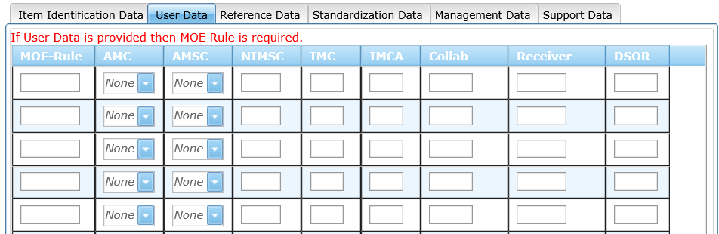
Figure 6 - 5. User Data Tab

Reference Data
Enter Reference Number data in this section. Data is mandatory depending on the type of request and the activity code of the user.
        - Commercial and Government Entity (CAGE)
        - Part/Ref Number
        - Reference Number Category Code (RNCC)
        - Reference Number Verification Code (RNVC)
        - Document Availability Code (DAC)
        - Reference Number Action Activity Code (RNAAC)
        - Reference Number Format Code (RNFC)
        - Reference Number Suffix Code (RNSC)
        - Reference Number Justification Code (RNJC)
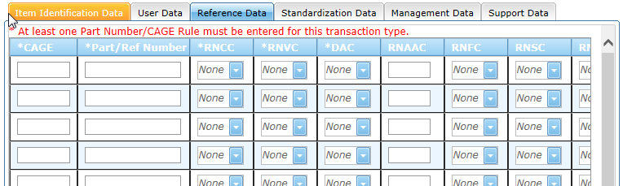
Figure 6 - 6. Reference Data Tab

Standardization Data
Standardization data is optional.
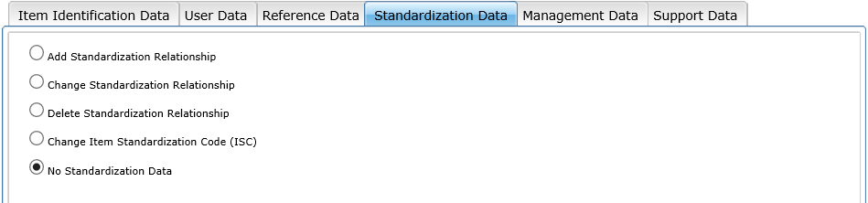
Figure 6 - 7. Standardization Data Tab

Add Standardization Relationship
After selecting the Add Standardization Relationship radio button, the following screen will display.
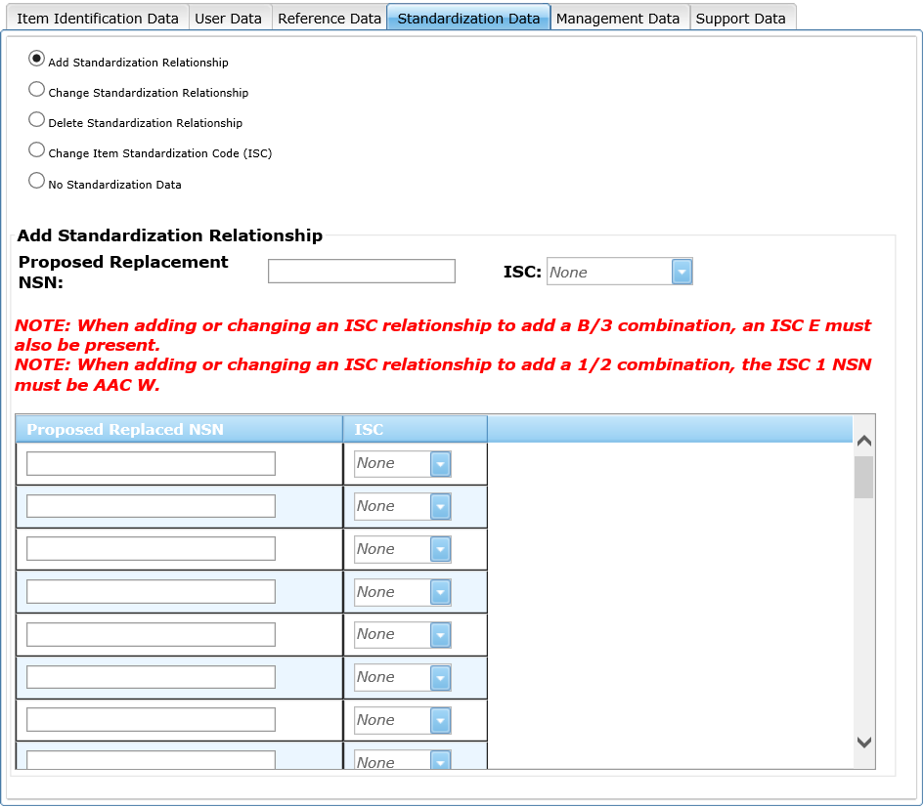
Figure 6 - 8. Add Standardization Data
Proposed Replaced NSN and ISC are contained in a Data Grid table. This field is mandatory if Add Standardization Relationship is checked. Current options are as follows:
        - If ISC 1 is selected next to Proposed Replacement NSN, then ISC dropdown options in the table are 3 and 2.
        - If B is selected next to Proposed Replacement NSN, then ISC dropdown options are E and 3.
Use the scroll bar on the right to access all 50 rows.

Management Data
It is critical that you use a decimal point when entering Unit Price. If omitted, the system will assume you entered whole dollars and automatically add a decimal point with two zeros after the entered value.
        - Acquisition Advice Code
        - Source of Supply
        - Unit of Issue
        - Unit Price, including decimal
Quantitative Expression:
        - Quantity per Unit Pack Code
        - Controlled Item Inventory Code
        - Shelf Life Code
        - Military service unique management data is displayed based on your activity code.
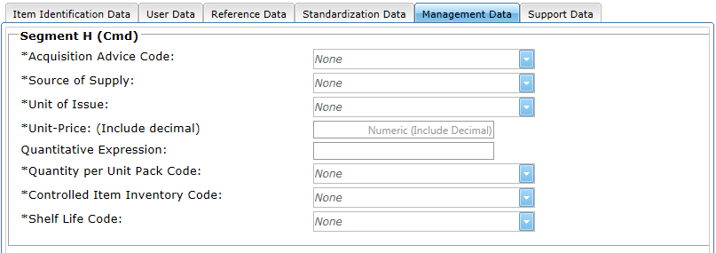
Figure 6 - 9. Management Data Tab

Navy Management Control Data
All fields are required for Navy managed new NSN Assignment or Reinstatement. If the request type is Update an Existing NSN, only the desired change needs to be entered.
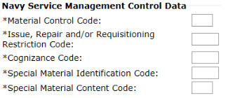
Figure 6 - 10. Navy Management Control Data

USAF Management Control Data
Only the desired change needs to be entered.
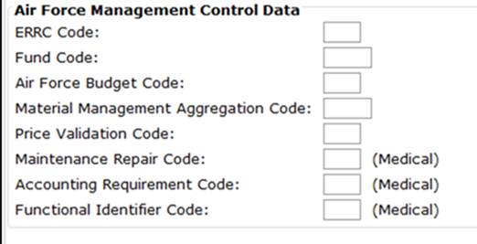
Figure 6 - 11. USAF Management Control Data

Army Management Control Data
All fields are required for an Army managed new NSN Assignment or Reinstatement. If the request type is Update an Existing NSN, only the desired change needs to be entered.
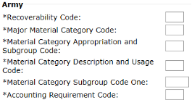
Figure 6 - 12. Army Management Control Data

USMC Management Control Data
Stores account is required for new NSN Assignment or Reinstatement. If the request type is Update an existing NSN only the desired change needs to be entered.
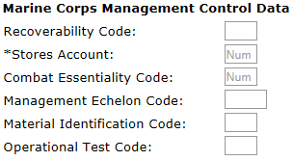
Figure 6 - 13. Marine Corps Management Control Data

US SOCOM Management Control Data
All fields are required for new NSN Assignment or Reinstatement. If the request type is Update an Existing NSN, only the desired change needs to be entered.
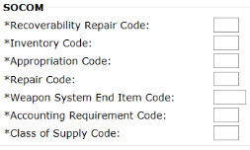
Figure 6 - 14. SOCOM Management Control Data

US Coast Guard Management Control Data
All fields are required for new NSN Assignment or Reinstatement. If the request type is Update an Existing NSN, only the desired change needs to be entered.
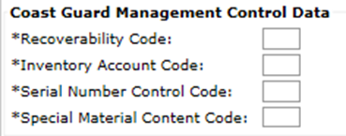
Figure 6 - 15. Coast Guard Management Control Data

Support Data
Enter Support Data in this section.
- End Item NSN | - End Item Delivery Cycle Date
- End Item Cage Code | - End Item Name or Model Number
- End Item Type of Change Code (TOCC) | - Weapon System Designator Code
- Activity Code To (ACT) | - End Item Quantity
- Percent of End Item East | - Date of Release (DOR): (YYYY MM DD)
- Contract Control Number | - Request Type of Change Code
- Date Repair Parts Required | - PCC
- ISN | - Maintenance Code
- Source Code | - Essentiality Code
- Production Lead Time (PLT) | - Retail Quantity
- Wholesale Quantity | - Quantity per End Item
- Technical Data Justification Code (TDJC) | - Date Technical Data Supplied (DTDS)
- Item Technical Description or Off-the shelf | - Transfer of Technical Data Availability
- Limited Rights | - Adequate for Mfg
- Equipment/System Application | - Interchangeability
- Type of Critical Application | - Type of Item
- Location | - Transferred to DLA
Note: For USMC, mandatory data elements will be displayed with an asterisk.

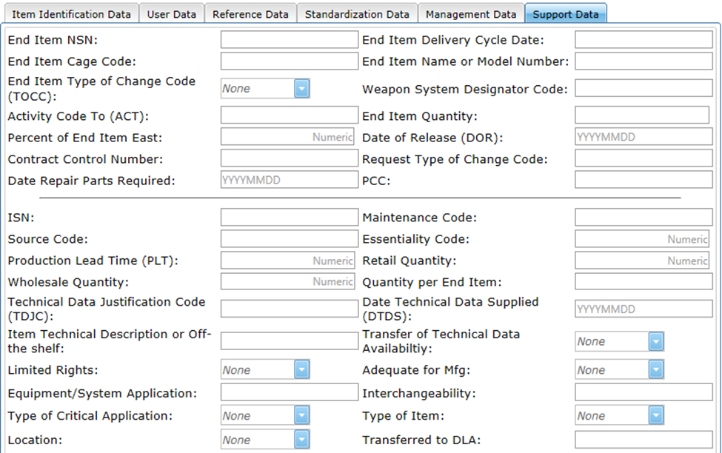
Figure 6 - 16. Support Data Tab

Update an Existing NSN
This request type allows you to request maintenance on an existing NSN. If the OAC is not ‘PA’, a message is displayed asking if this will be a single input. If Yes, the Update Item Input form opens. If No, the Mass Load form opens.
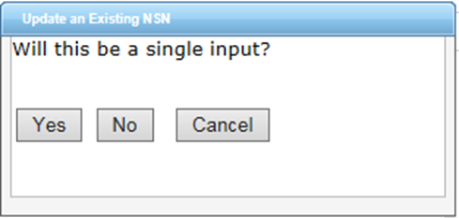
Figure 6 - 17. Update an Existing NSN Question

If the OAC is ‘PA’ a message is displayed asking if this Will this be a single input? and Will the Marine Corps be added as a User? If Yes Single Input, the Update Item Input form opens. If No, the Mass Load form opens.

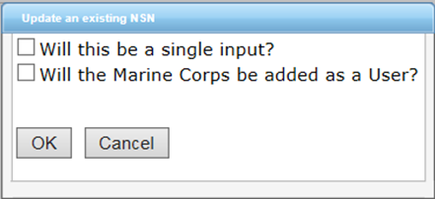
Figure 6 - 18. Update an Existing NSN—Marine Corps
If ‘Will the Marine Corps be added as a User?’ is selected, the box will expand to offer two additional questions: Is the Item Currently DLA Managed?, and Will the Item be DLA Managed? If Yes, the Update Item Input form opens. If No, the Mass Load form opens.
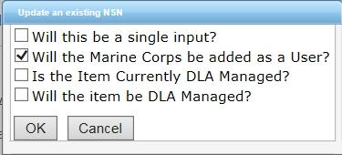
Figure 6 - 19. Update an Existing NSN—Marine Corps Added Questions

The Update an Existing NSN form layout is the same as New NSN Assignment and Reinstate an existing NSN. The only mandatory fields for this type of request are the NIIN and one other data element.
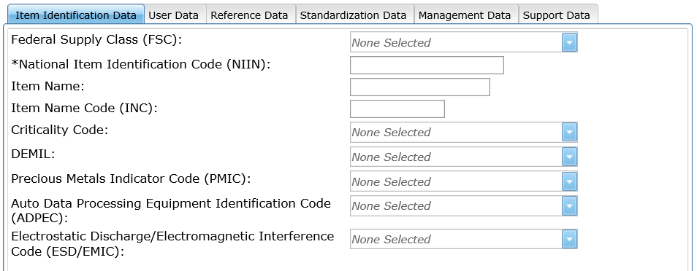
Figure 6 - 20. Item Identification Data Tab

Action Indicators
The User and Reference data tabs contain Type Action drop downs to allow the user to indicate whether they are (A)dding, (C)hanging, or (D)eleting the entered data from the NSN.
The default display is A.
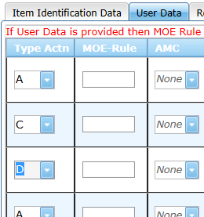
Figure 6 - 21. Type Action Indicators

Standardization Data
On the Standardization Data page, you can Add, Change, and Delete the Standardization Relationship; Change an Item Standardization Code (ISC), or record there is no Standardization data. The default setting is No Standardization Data.

- Add Item Standardization Code (ISC) Relationship
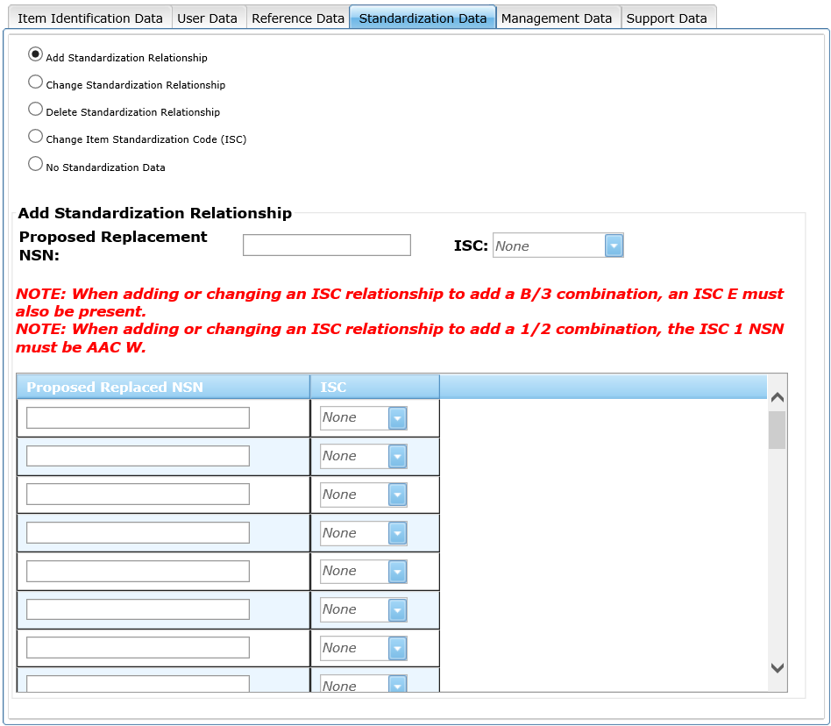
Figure 6 - 22. Add Standardization Relationship
Enter the proposed Replacement NSN and select an ISC from the drop-down menu. Proposed Replaced NSN and ISC are contained in the Data Grid table. This field is mandatory if Add Standardization Relationship is chosen. Current options are as follows:
- If ISC 1 is selected next to Proposed Replacement NSN, then the ISC dropdown options in the table are 3 and 2.
- If ISC B is selected next to Proposed Replacement NSN, then ISC drop-down options are E and 3.
Use the scroll bar on the right to access all 50 rows

- Change Item Standardization Code (ISC) Relationship
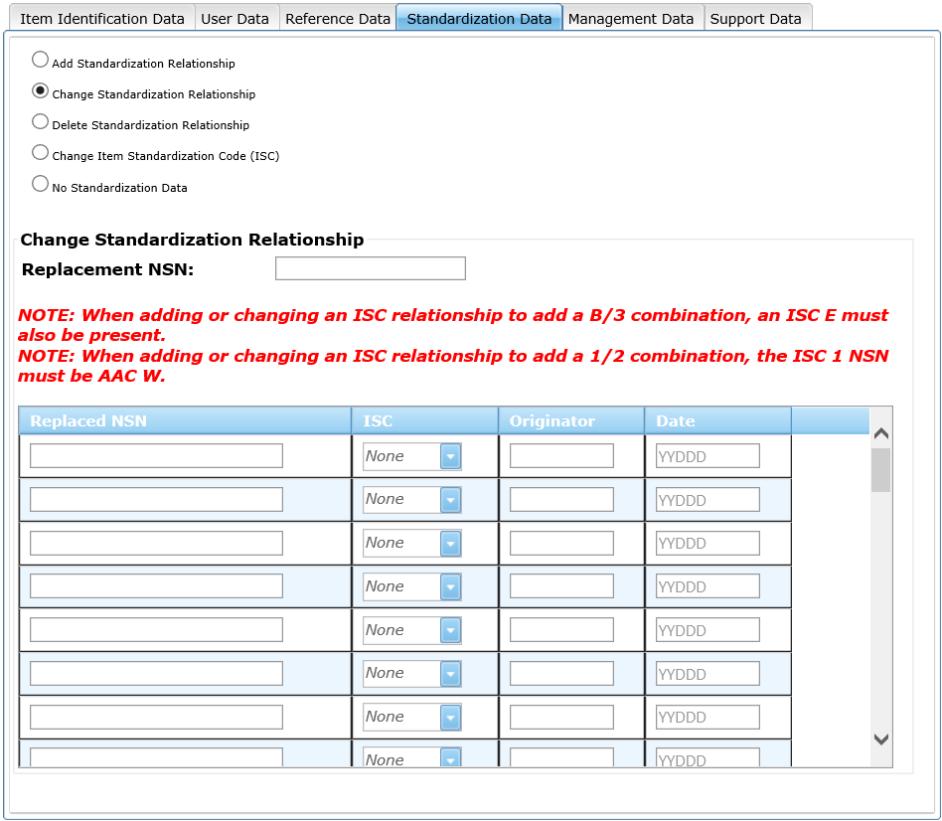
Figure 6 - 23. Change Standardization Relationship
Follow these steps to change Standardization Relations:
- Enter the Replacement NSN in the text field.
- Enter the Replaced NSN in the table.
- Select the ISC from the drop-down (current options are 2,3 or E).
- Add Originator and Date.
Use the scrollbar to access all 50 rows.

- Delete Item Standardization Code (ISC) Relationship
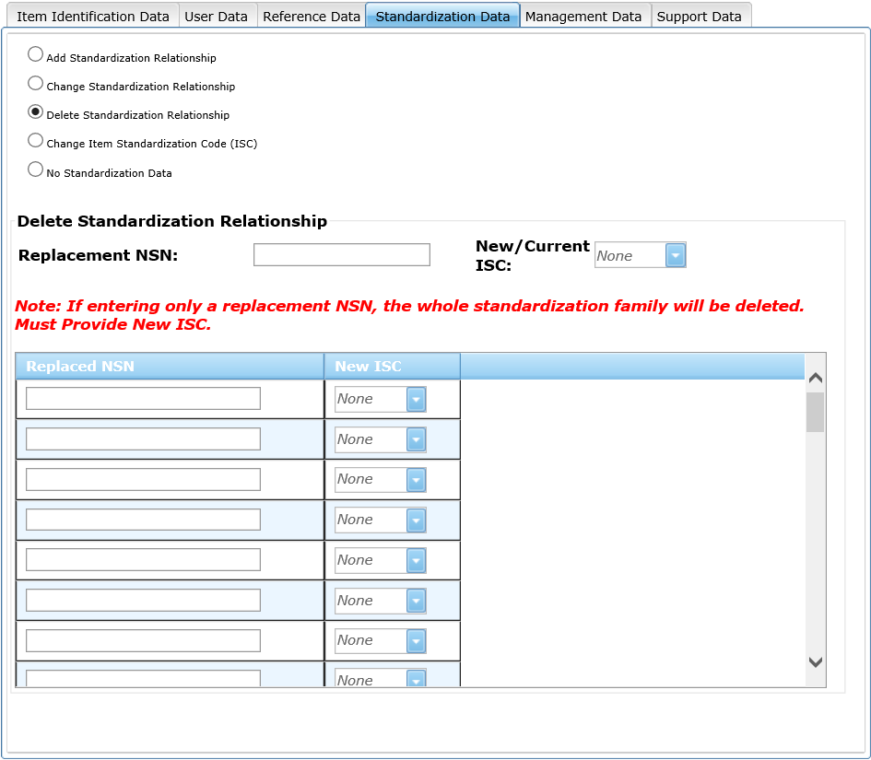
Figure 6 - 24. Delete Standardization Relationship
Use this page to delete a Standardization Relationship:
- Enter a Replacement NSN.
- Select the New/Current ISC. options are (1, B, 2, 5, 6, or C). If you are entering only a replacement NSN, the whole standardization family will be deleted. You must provide a New ISC.
- Enter Replaced NSN and New ISC in the Data Grid Table. The New ISC options are 2, 5, 6, and C.
Use the vertical scrollbar to access all 50 rows.

- Change Item Standardization Code (ISC) not in a Relationship
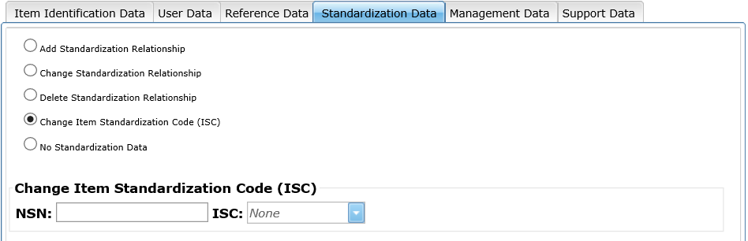
Figure 6 - 25. Change item Standardization Code
Use this page to Change the Item Standardization Code (ISC):
- Enter the NSN in the textbox.
- Select the ISC from the dropdown. Options are currently 2, 5, 6, and C.

Item Entry Control Review
The request type is for the services to submit pre-provisioning type transactions.
When this Request Type is selected, a message is displayed asking if this will be a single input.
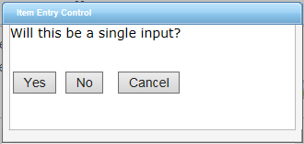
Figure 6 - 26. Item Entry Control Question
If Yes is selected, the Item Entry Control Review single input form will open.
Enter Item Entry Control Review data in this section.
        - NSN (Either NSN or CAGE and Part Number are Mandatory)
        - Control Number
        - CAGE (Either NSN or CAGE and Part Number are Mandatory)
        - Part Number (Either NSN or CAGE and Part Number are Mandatory)
        - PCC
        - Item Name (Mandatory if CAGE and Part Number are provided)
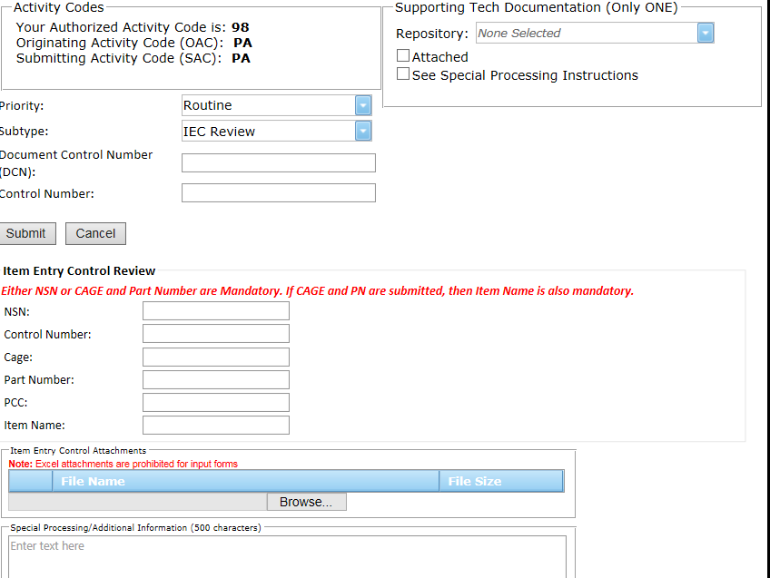
Figure 6 - 27. Item Entry Control Review Single Input Form
If No is selected, the Item Entry Control Review Mass Load form opens.
(See section 8.0 for further Mass Load instructions.)
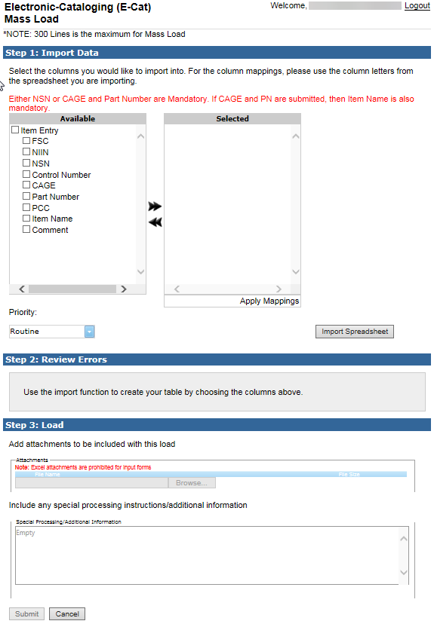
Figure 6 - 28. E-Cat Item Entry Mass Load Form

Freight
When you select request type Freight, a Freight Data dialog box displays asking if this will be a single input.
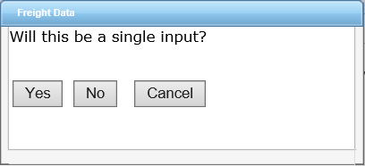
Figure 6 - 29. Freight Data Input Dialog Box
Click Yes for single input and No for multiple input.
- When you select Yes, the Freight Data page displays.
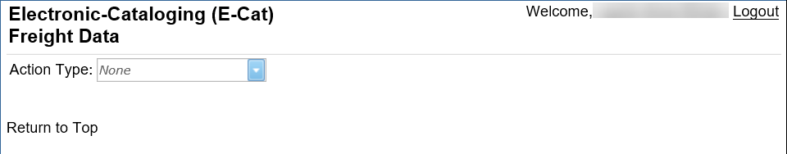
Figure 6 - 30. Freight Data Page
- When you select No, a Freight Data Mass Load dialog box displays.
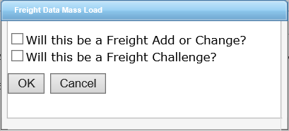
Figure 6 - 31. Freight Data Mass Load Dialog Box
Select the first checkbox if you are entering a Freight Add or Change.
Select the second checkbox if you are entering a Freight Challenge.
Click OK to proceed to the Mass Load form.

Freight Data Single Entry
Select an action type: Freight New (A), Freight Change (C), or Freight Challenge (X). Figure 6-36 shows a Freight New Add form.
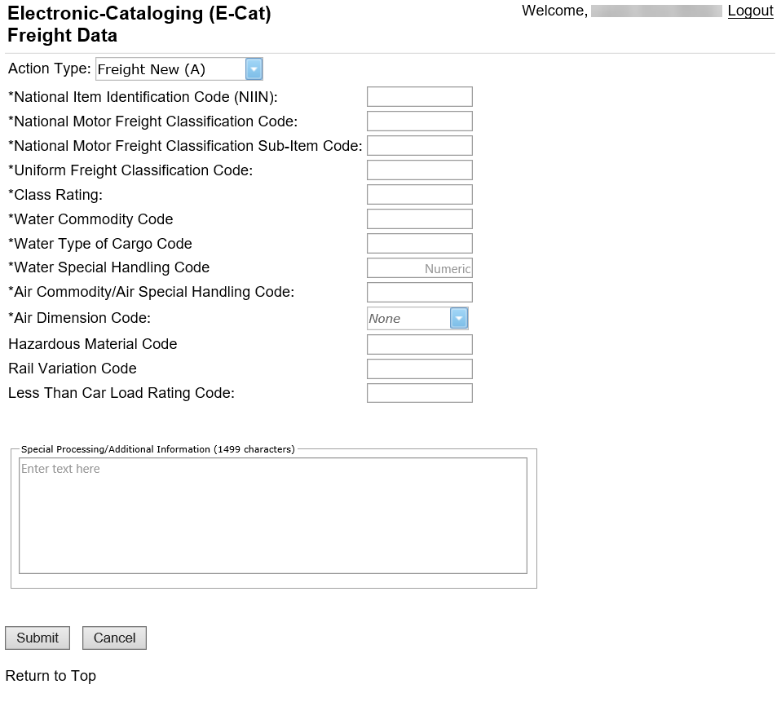
Figure 6 - 32. Add New Freight Data
Mandatory elements are marked with an asterisk (*). Enter data and click Submit.

The next figure shows the Freight Change form.
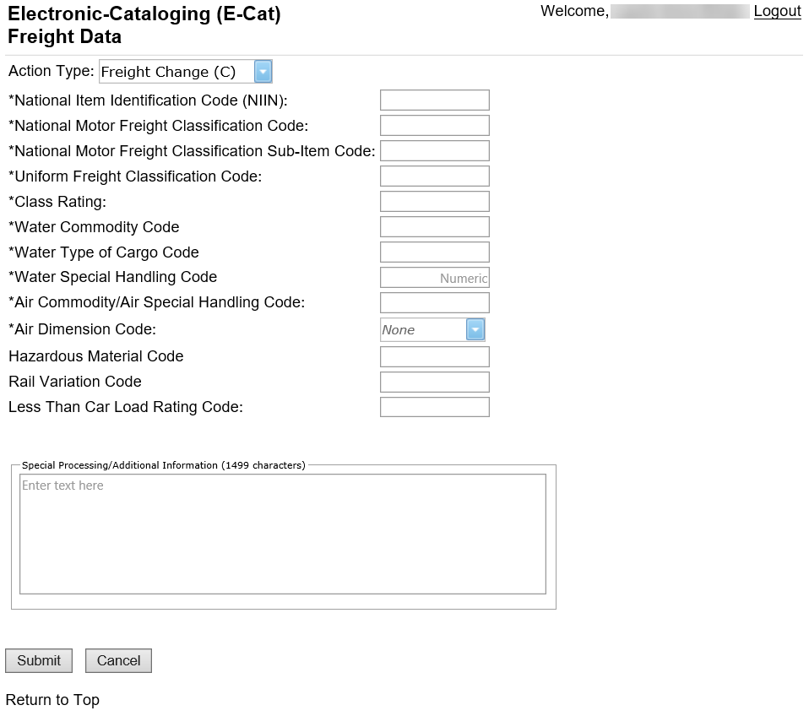
Figure 6 - 33. Change Current Freight Data
Mandatory elements are marked with an asterisk (*). Enter data and click Submit.

Figure 6-38 shows the single input Freight Challenge form.
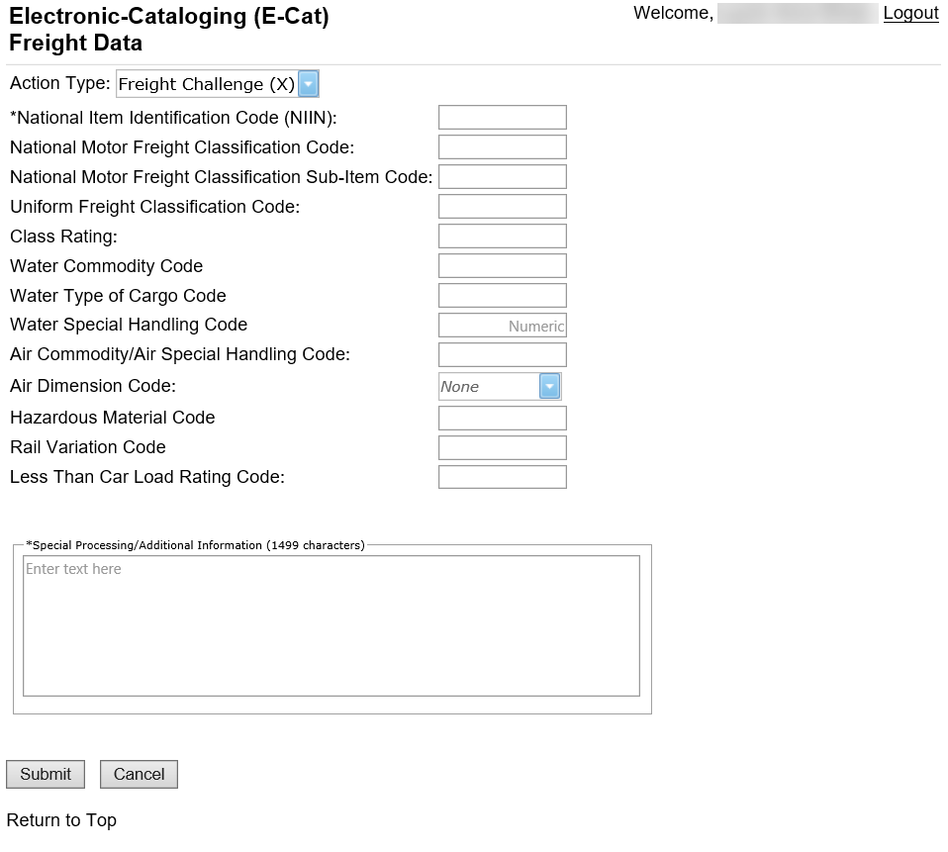
Figure 6 - 34. Challenge Freight Data
Use the Challenge Freight Data option to dispute the current Freight Data. Mandatory fields are NIIN and Special Processing/Additional Information.

Freight Data Mass Load
When you select not single input, add or change, Figure 6-39 displays.
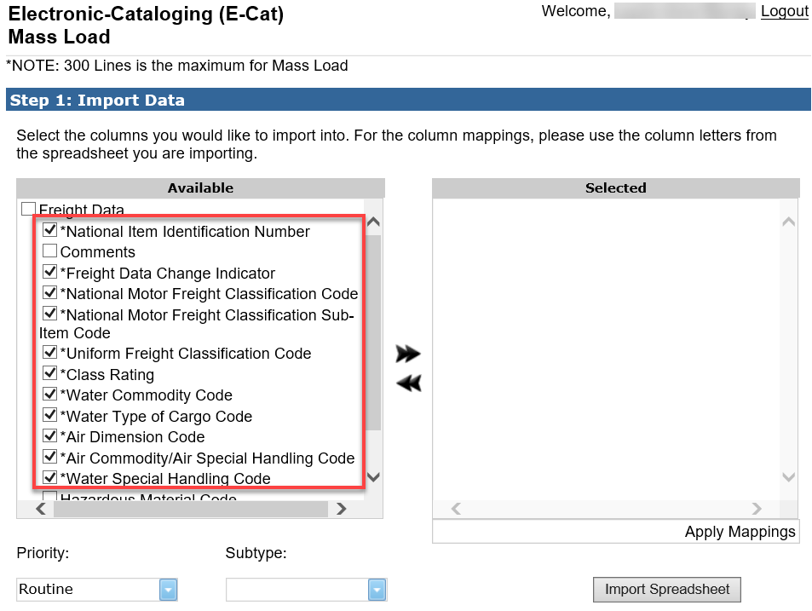
Figure 6 - 35. Freight Mass Load Add or Change
Freight data elements are required.

When you select not single input, Challenge, the Mass Load form displays similar to Figure 6-40.
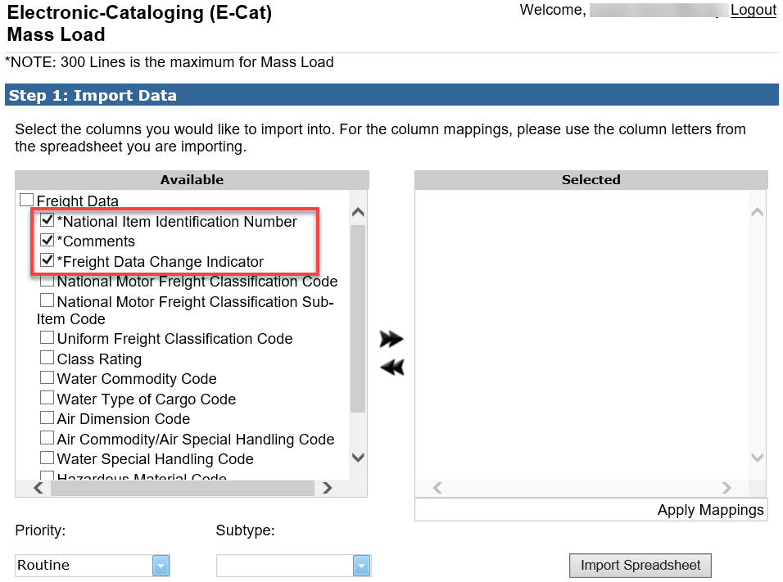
Figure 6 - 36. Freight Challenge Mass Load
The only required elements for the Freight Challenge Mass Load are NIIN, Comments, and Freight Data Change Indicator. If any Freight data is selected then the following Freight data becomes mandatory:
  - Freight Data Change Indicator
  - National Motor Freight Classification Code
  - National Motor Freight Classification Sub-Item Code
  - Uniform Freight Classification Code
  - Class Rating
  - Water Commodity Code
  - Water Type of Cargo Code
  - Air Dimension Code
  - Air Commodity/Air Special Handling Code
  - Water Special Handling Code
  - Hazardous Material Code
  - Less Than Car Load Rating Code
  - Rail Variation Code.
- Example of Freight data from spread sheet:
- A = add
- C = change
- X = challenge

See section 8 for more information about the E-Cat Mass Load function.

Unique Input for Non-U.S. Customers
Non-U.S. users will see slightly different tabs.

New Item and Reinstatement Input Form
Your user data from your account registration is used to populate the top of the form. Fill in the rest of the top of the form.
        - Priority – Default is Routine. The drop down allows you to indicate whether your request is Emergency or Accelerated
        - Subtype
        - Supporting Tech Documentation
        - Document Control Number
        - Control Number

Item Identification Data
The Item Identification Data section is displayed first. Enter all of the information that you have for the item.
        - Federal Supply Class (FSC): If a specific (FSC) is unknown, select the applicable general category that applies (displayed at the bottom of the drop down).
        - National Item Identification Code (NIIN) (Not used for New NSN Assignment)
        - Item Name: FLIS catalog name. (Mandatory if the INC is blank or 77777.)
        - Item Name Code (INC): Mandatory if Item Name is blank
        - Criticality Code
        - DEMIL
        - Precious Metals Indicator Code (PMIC)
        - Automatic Data Processing Equipment Identification Code (ADPEC)
        - Electrostatic Discharge/Electromagnetic Interference Code (ESD/EMIC)
*If you hover over any value in a drop down, the definition is displayed.
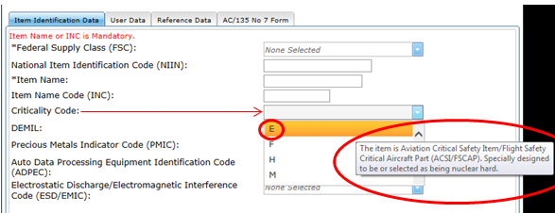
Figure 7 - 1. Item Identification Data—Definition Displayed (Non-U.S. Customer)

User Data
User data is optional. If entered, then MOE rule is required. Input fields are:
        - Major Organizational Entity (MOE) Rule
        - Acquisition Method Code (AMC)
        - Acquisition Method Suffix Code (AMSC)
        - Non-consumable Item Materiel Support Code (NIMSC)
        - Item Management Code (IMC)
        - Item Management Coding Activity (IMCA)
        - Supplemental Collaborator (Collab): Individuals who collaborate with the individual responsible for the record to help define the record details.
        - Supplemental Receiver (Receiver)
        - Depot Source of Repair (DSOR)
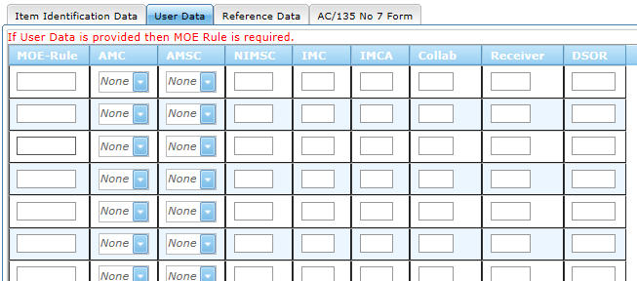
Figure 7 - 2. User Data Tab (Non-U.S. Customer)

Reference Data
Enter Reference Number data in this section:
        - Commercial and Government Entity (CAGE)
        - Part/Ref Number
        - Reference Number Category Code (RNCC)
        - Reference Number Verification Code (RNVC)
        - Document Availability Code (DAC)
        - Reference Number Action Activity Code (RNAAC)
        - Reference Number Format Code (RNFC)
        - Reference Number Suffix Code (RNSC)
        - Reference Number Justification Code (RNJC)
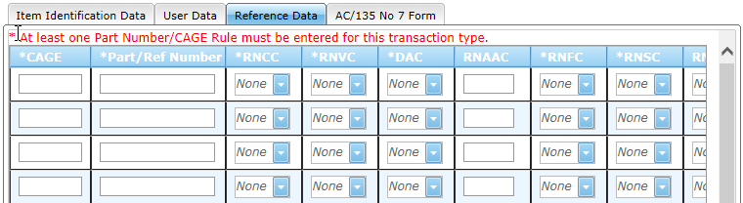
Figure 7 - 3. Reference Data Tab (Non-U.S. Customer)

AC/135 No. 7 Form
Form input requirements are in accordance with the ACodP1 regulation.
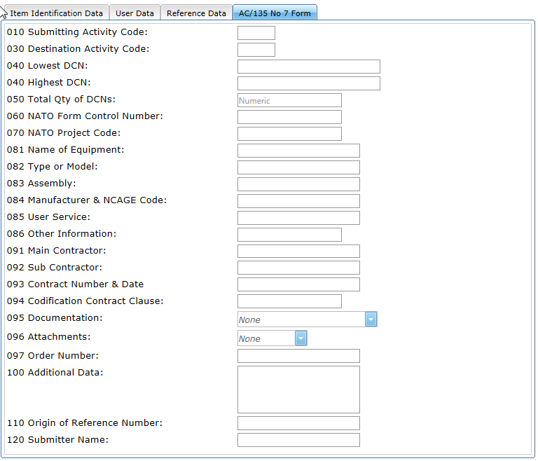
Figure 7 - 4. AC/135 No 7 Form (Non-U.S. Customer)

Update an Existing NSN
This request type allows you to request maintenance on an existing NSN.
A message is displayed asking if this will be a single input. If Yes, the Update Item Input form opens. If No, the Mass Load form opens.
This form layout is the same as New NSN Assignment and Reinstate an Existing NSN. The mandatory fields for this type of request are the NIIN and one other data field.
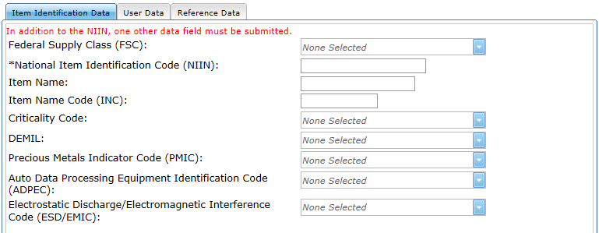
Figure 7 - 5. Item identification Data (Non-U.S. Customer)

Action Indicators
The User and Reference data tabs contain Type Action drop downs to allow the user to indicate whether they are (A)dding, (C)hanging, or (D)eleting the entered data from the NSN.
The default display is A.
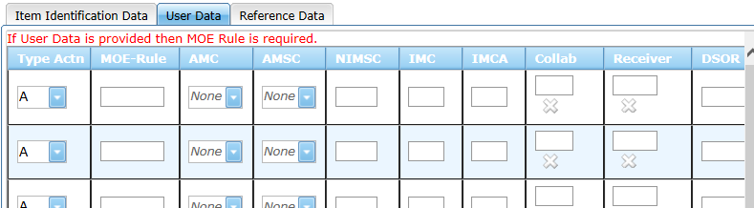
Figure 7 - 6. User Data Action Indicators (Non-U.S. Customer)
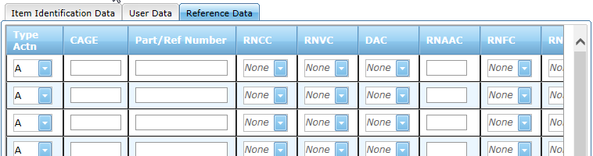
Figure 7 - 7. Reference Data Tab (Non-U.S. Customer)

Submit Your Request
When satisfied with entries, click the Submit button.
Any fields that do not contain valid entries or that are required and left unfilled are noted with a red exclamation mark (!). An error message explains the problem.
    - Correct errors and click Submit until you receive a success message.
    - When successful, a "Save to FPW was successful" message displays containing a Show Results link. Click the link to view the Confirmation Results page containing all the information about the item.
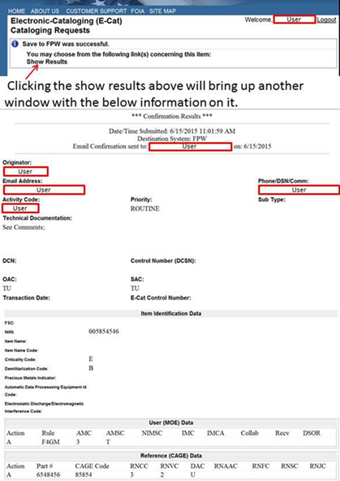
Figure 7 - 8. Show Results Confirmation Page
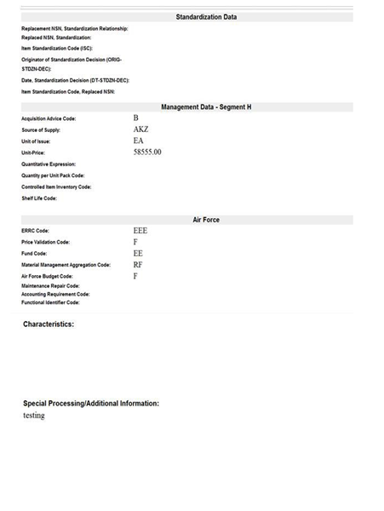
Figure 7 - 9. Show Results Confirmation Page (continued)
An email detailing your request is sent to you.
    - At any time you can return to the E-Cat Main page by clicking Cancel. Entered request data is not saved.

Mass Load Form
Mass load can be used to load multiple New NSN Assignments, Update an Existing NSN, Cancel an Existing NSN, Item Entry Control Review, and Freight requests. The Mass Load form is presented when the user responds on the opening dialog box that input is not a single request. This input form will walk the user through mapping an EXCEL spreadsheet to the form. The same mandatory fields required for a single request input also apply to a mass load.
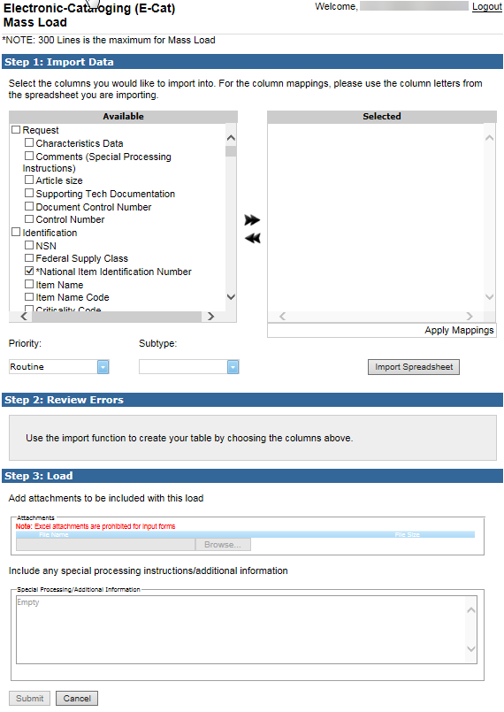
Figure 8 - 1. Mass Load Form

As many as 300 requests can be imported from an Excel spreadsheet.
Prepare your Excel spreadsheet to import. Be certain that all codes and numbers are valid and contain the correct number of characters. Know in which columns your data resides.
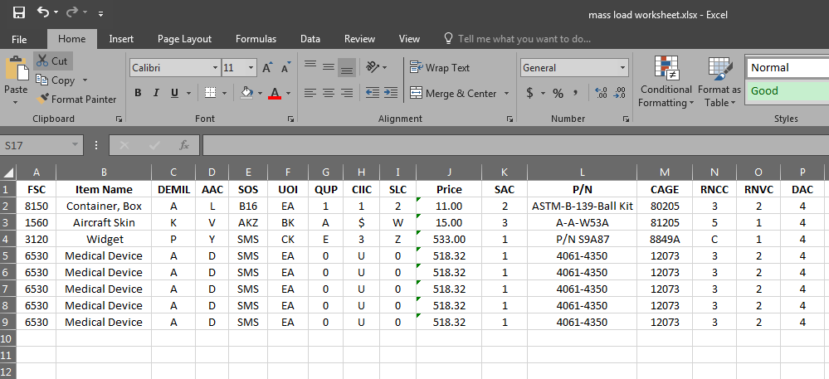
Figure 8 - 2. Excel Spreadsheet for Import
It is critical that you format unit price with a decimal point. As with the single input, if omitted, the system will assume you entered whole dollars and automatically add a decimal point with two zeros after the entered value.

Step 1 Import
- Based on the request type you have selected and the Activity Code in your registration profile, ECAT will automatically check the mandatory boxes for you in the ‘Available’ window. The Available column on the left lists categories and their data elements available as spreadsheet headings for import.
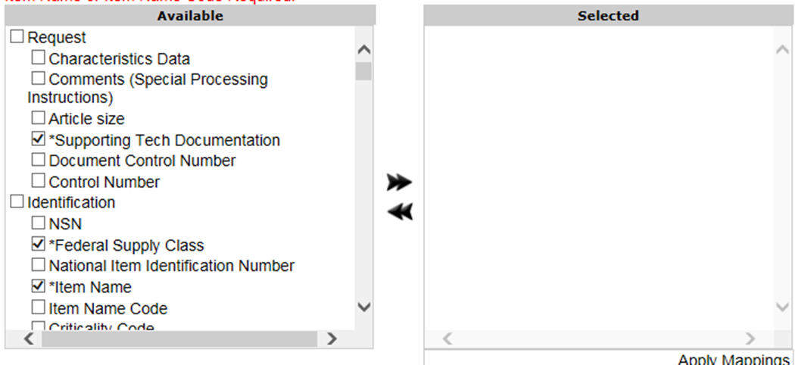
Figure 8 - 3. Select Elements for Import
- Click the checkbox next to a category to select all of its data elements OR select specific fields by clicking in the checkbox next to that field. You can also deselect individual fields as needed.
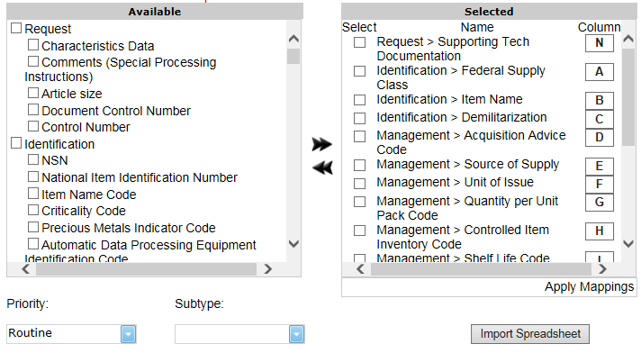
Figure 8 - 4. Elements Selected—Columns Identified
- When you have chosen your data elements, click once on the right arrow to move all checked data elements from the ‘Available’ window to the ‘Selected’ window.
- If you need to remove a data element from your ‘Selected’ box: Click the checkbox next to that element, then click the left arrow to move it back to the ‘Available’ window.
- For each data element in the ‘Selected’ box, enter the column letter next to the appropriate data element. (As an example, if ‘Characteristics Data’ is in column A of your spreadsheet, enter A next to the data element ‘Request > Characteristics Data’.)
- If you are changing or deleting User or Reference Number data, you must also include a change indicator column to both your spreadsheet and the ‘Selected’ window.
- Click on the Import Spreadsheet button.
- A dialog box opens.
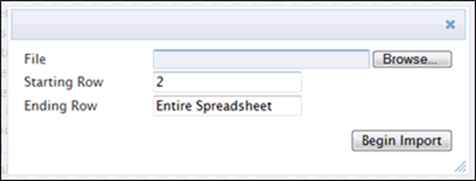
Figure 8 - 5. Import Spreadsheet Dialog Box
- Select the Browse... button to locate the file you want to import. Select it.
- You may need to open the file to get information to enter. Enter Starting Row and Ending Row from the spreadsheet. Starting at row 2 allows you to leave column headings in row 1. If you want to import all the information on the spreadsheet, leave Ending Row as Entire Spreadsheet. Mass Load will take the data from the entire spreadsheet and ignore empty rows.
- Close the spreadsheet.
- Click Begin Import.
- The file is imported and displayed at the bottom of the Step 1 section.
Figure 8 - 6. File Imported
You can click on the plus sign next to Imported File to drop down a window to view the file as shown below. Click again to close the window.
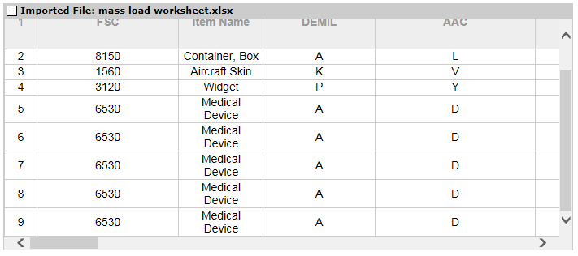
Figure 8 - 7. View Imported File
- Click Apply Mappings.
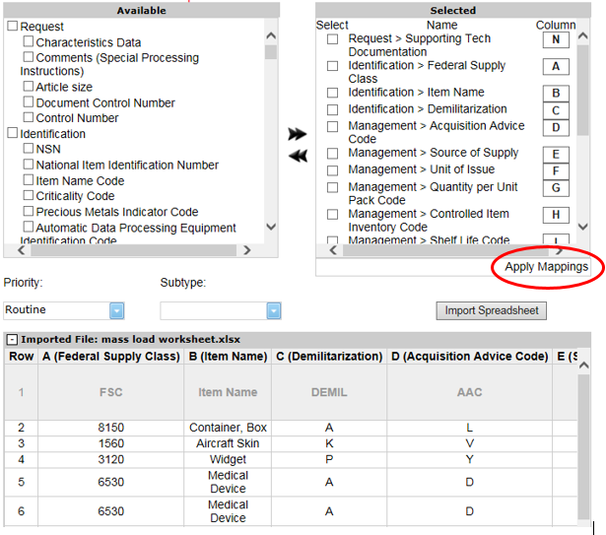
Figure 8 - 8. Apply Mappings
- If you have missed any column mappings they will appear in a banner and will be highlighted with red in the ‘Selected’ box
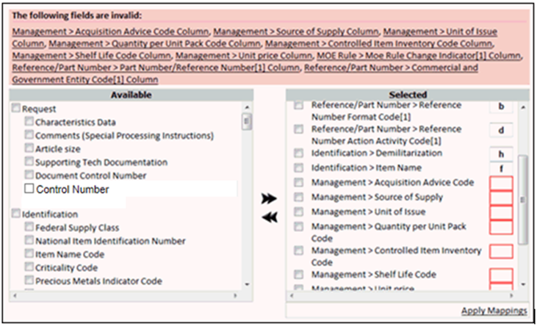
Figure 8 - 9. Invalid Field Indicator
- For column errors, you can reassign column letters out of order in the ‘Selected’ window as long as they correspond to the correct data element. You may also move data elements between the ‘Available’ and ‘Selected’ windows and Apply Mappings again. Note that in the next step you may find further errors.

Step 2 Review Errors
- The information on the spreadsheet must pass E-Cat validation rules. If errors exist, the message Please correct the following errors with the spreadsheet and import again. is displayed. Additionally, errors are listed with their cause in the ‘Errors’ window. Missing mandatory data element(s) are also listed in the ‘Error’ window as seen below. Here, CAGE data was omitted.
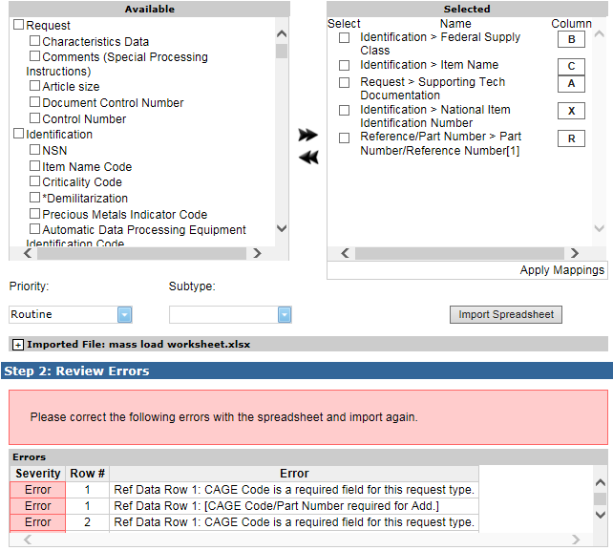
Figure 8 - 10. Review Errors
- Review the list. Select and map more data elements and/or open the spreadsheet, find the errors, and fix them on the spreadsheet.
- Try again. Click Import Spreadsheet to upload an updated file.
- When no more errors exist, a success message is displayed No errors were found. Your spreadsheet is ready for loading.
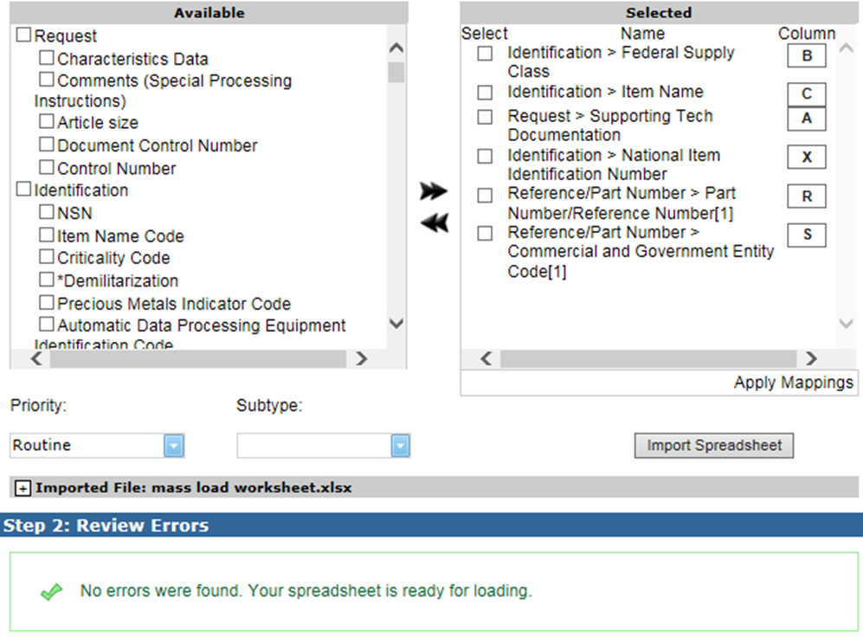
Figure 8 - 11. No Errors Found

Step 3 Load
Add attachments to be included with the load.
You can add up to three supporting documents. An individual file can be no larger than 4 MB, and the total of the attachments can be no greater than 12 MB. EXCEL spreadsheets are prohibited.
- Click on the Browse button.
- Choose a file to upload from your computer.
- Select the Open button.
- The file is added.
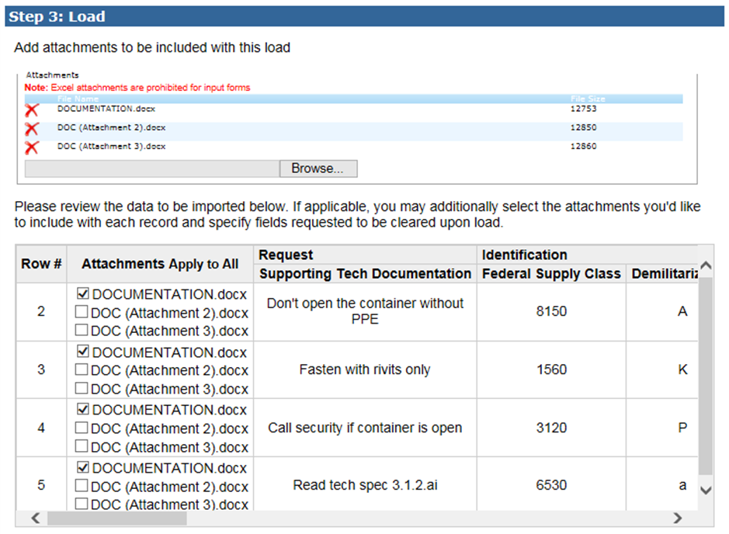
Figure 8 - 12. Supporting Documents Added
- To remove the attachment, click the Delete icon to the left of the file name marked by .
- The attachments are listed in the Attachments field, and the spreadsheet records to be loaded are listed underneath. The files are listed in the second column.
- Apply any uploaded documents to individual spreadsheet rows by checking boxes. To apply all attachments to all rows, click the Apply to All link in the Attachments column heading. Or select individual attachments to include with each record by clicking in the check boxes.
- Enter Special Processing notes—up to 1499 characters in this field.
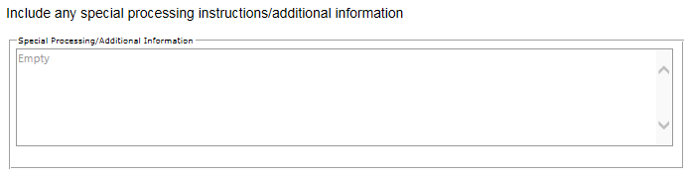
Figure 8 - 13. Special Processing/Additional Information Field
- Click Submit.
- Successful submit displays a Mass Load Successful message and a link to click to perform another catalog request. The E-Cat system then sends you an email confirming receipt of your mass load request.
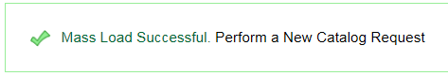
Figure 8 - 14. Mass Load Successful Message

Mass Load Notes
- Mass Load can process up to 300 rows. If your spreadsheet contains more than 300 rows, it will only process the first 300.
- When you import a spreadsheet that has more than 100 errors, ECAT will only show you the first 100. Correct these errors, re-import, and then ECAT is able to process up to 100 more errors.

APPENDIX A – ACRONYMS
1685 Action Type of cataloging action submitted into the cataloging system, used particularly by the Army and displayed on the Army result table.
AAC Acquisition Advise Code, a code that denotes how (as opposed to where and any restrictions that exist) the individual responsible for purchasing the item will acquire it.
Acty Code, ACT CD Activity Code. A submitter-related code, which is the 2-digit code found in DoD 4100.39-M, Volume 10, Table 104 Part 4, also know it as the “submitter activity code.” Examples are AX for DSCC (Construction), KZ for DSCP (Industrial), 48 for FAA, CL for CECOM, TX for DSCC (Electronics).
AD Active Directory
ADP Automatic Data Processing
ADPEC Automatic Data Processing Equipment Identification Code
AMC Acquisition Method Code, a term the Air Force and DLA use for new items
AMSC Acquisition Method Suffix Code, a term the Air Force and DLA use for new items
APP Application, a code the Army uses for suspense tracking output
ASG Afloat Shopping Guide (Navy Cataloging)
ATC Action Taken Code, a code the Navy uses to indicate a specific action taken. For more information on the codes, see DoD 4140.26-M.
CAC Common Access Card used for identification, access to buildings and computers
CAGE Commercial and Government Entity, a number associated with the name of a commercial source or government entity
Cat, Catlg Cataloging
Cd Code
CHC Change Code
CIIC Controlled Item Inventory Code.
COG Cognizance Symbol or Code, a code the Navy uses as a prefix to NSNs for internal Navy management purposes. It identifies the ICP office or agency that exercises supply management of the item for the Navy. The first position is numeric, the second is alphabetic.
Collab Collaborator, individuals who collaborate with the individual responsible for the record to help define the record details.
Contract # Number displayed on the Marine Corps query results table used for Marine Corps contract tracking purposes.
Control (or Ctrl) Number, Control #
Alphanumeric field that contains a unique item identifying serial number for a query or maintenance request. File transfer causes this field to autopopulate, or the appropriate technician manually inputs the data.
Cust Cntrol. No Customer Control Number, a unique identifier that the user will use to identify a request.
CWT Cataloging Workload Tracking
DAC Document Availability Code, or Designated Activity Code, a code the Air Force uses that indicates the type and availability of technical documenta-tion for the item.
Date Collab Sent Date Collaboration Sent, a date the Navy uses to indicate when the Navy sent a DD 1685 or other collaboration form to DLA Logistics Information Services.
Date Catlg Comp Date Cataloging Complete, a date the DLA and Navy use to indicate when cataloging actions are completed.
Date Rec’d Date Received, a date used to indicate when an action request is initially input.
Date Reject by FLIS Date reject by Federal Logistics Information Services, a date the Navy uses to indicate when the Navy received a reject for an action from FLIS.
Date Reply Rec’d Date Reply Received, a date the Navy uses to indicate when the Navy received a Concur/Nonconcur from FLIS.
Date Tech Data Received
Date Technical Data Received, a date the Navy uses to indicate when DLA Logistics Information Services received the technical documentation for initiating activity.
Date Tech Data Returned
Date Technical Data Returned, a date the Navy uses to indicate when DLA Logistics Information Services returned the technical documentation to the initiating activity.
DCN Document Code Number, the number the government assigns to the document record associated with the item.
DCSN Data Control Serial Number (last 7 characters of DCN)
DEMIL Demilitarization, a term used to denote a supply item that is no longer given the status of classified.
DLA Defense Logistics Agency, one of the project acquirers that generates records.
DOD Department of Defense
DOR Date of Record
DSCP/CT Defense Supply Center Philadelphia/Clothing and Textiles Directorate
DSOR Depot Source of Repair
Dt Date
EAN European Article Number, the equivalent of a UPC code used in the United States. See also UPC.
E-Cat Electronic Cataloging Web application
ESD/EMIC Electrostatic Discharge/Electromagnetic Interference Code
FAA Federal Aviation Administration
FCS Federal Catalog System
Firewall An electronic barrier that certain system administrators might install to prevent some forms of incoming and outgoing electronic mail
FLIS Federal Logistics Information Services, a branch of the DLA responsible for maintaining an automated inventory catalog of military materiel.
FMS Foreign Military Sales
Form of Req Form of Request, a term related to DLA Maintenance items that indicates the form of request.
FPDW FLIS Portfolio Data Warehouse
FPW FLIS Portfolio Workbench
FSC Federal Supply Class, the last two digits of the NSN, a code for dividing the FSG into 99 classes (see also NSN and FSG).
FSG Assigned Federal Supply Group, the first two digits of the NSN, a code that refers to item classifications, for example, bullets or missiles.
GIRDER Government/Industry Reference Data Edit and Review.
HTTPS Hypertext Transport Protocol Secure
ICP Inventory Control Point, the office or agency that manages a supply item.
IMC Item Management Code
IMCA Item Management Coding Activity
INC Item Name Code
Info Information
IRR Item Review Report, a unique serial number for a query or maintenance request. The field is automatically loaded by file transfer or the appropriate technician manually inputs it. The Medical (KX) group is the only user of this number.
IRS Project # Item Reduction Study Project Number, a number that all catalogers use which ties in with the Item Standardization Programs.
ISN Item Serial Number, the number assigned to the supply item.
ISP Internet Service Provider, the local provider in your regional area that provides access to the Internet
IT COOP Information Technology Continuity of Operations Plan
Item Name The FLIS catalog name for an item.
JRCAB Joint Readiness Clinical Advisory Board
List A list the application retrieves from the various data tables and displays on the Select Record page for the purpose of choosing a record when one or two of the PCC, DOR, or ISN parameters is used to query a New Item record.
LOGSA Logistics Support Activity, an activity on the Army Reports.
LSR Logistics Support Record, a term used on the Marine Corps File Load form.
Maint Maintenance
MC Marine Corps
MCLB Control Number
Marine Corps Logistics Base Control Number, a document number assigned to an item by a customer.
Med Medical
MILSTICCS Military Standard Item Characteristic Coding Structure
MOE Major Organizational Entity
MONITOR NAME The name of the individual submitting the initial request. This field, on the search results form for medical searches, is automatically loaded by file transfer.
MSC Major Subordinate Command
NADB NATO Ammunition Data Base
NAMSA NATO Maintenance and Supply Agency
NATO North Atlantic Treaty Organization. NATO refers to International Codification DLA Logistics Information Services-KI.
NAVICP Navy Inventory Control Point
NCB National Codification Bureau
NCS NATO Codification System
NDC National Drug Code, a code used on the DLA Medical New Items form.
.NET A software framework developed by Microsoft (pronounced: “dot NET”)
NGA National Geospatial Intelligence Agency
NICN Navy Inventory Control Number
NIIN National Item Identifier Number, a subset of NSN, it is the NSN minus the first four digits (see also NSN).
NIMSC Non-Consumable Item Material Support Code
NMCRL NATO Master Catalog of References for Logistics
NSN National Stock Number, or NATO Stock Number (same thing), a number that identifies each piece of equipment, part, or component.
OAC Originating Activity Code
ODBC Open Database Connectivity, a standard technical term for computers that refers to the type of database and connectivity to it.
OOU Order of use
ORC Output Return Code or Owner Reject Code
ORSI Organizational Routing Senders Identification, a term the Navy uses to identify the person(s) responsible for working the item at the originating Navy activity
Part Number, Part No.
The FLIS catalog part number for an item.
PCC Provisioning Control Code, a temporary code assigned to a supply item.
PCCN Provisioning Contact Control Number, a code the Army uses to indicate an item type, “P,” or provisioning item.
PDF Portable Document Format, a standard for representing electronic documents, allowing them to be transmitted and reproduced accurately.
PFG Process Flow Guide, a Navy Types of Action page term.
Phone # Phone Number, typically used to indicate the phone number of the record initiator, submitter, team leader, etc.
PICA Primary Inventory Control Activity, a code for the individual who controls the inventory count for the item.
PLISN Provisioning Line Item Serial Number, also called Provisioning List Item Sequence Number, a code the Army and Marine Corps use to indicate an item type, “P,” or provisioning item.
PM Program Manager
PMIC Precious Metals Indicator Code, a code used on the DLA Medical New Items form.
PMO Program Management Office
POC Point of Contact
ProvPC A computer application used as a front end to SAMMS for DLA provisioning type transactions.
QDB Quality Database, the DLA Logistics Information Service-S Data Quality/Data Purification program associated with CWTDB.
QUP Quantity per Unit Pack, a term used on the Medical New Items form.
Rec’d Received.
Rel Related.
Req Required or Requested.
RNCC Reference Number Category Code
RNJC Reference Number Justification Code, a code that designates a relationship between the reference number and the justification code.
RNSC Reference Number Status Code
RNVC Reference Number Variation Code
ROC Routing Output Code, a term the Army uses to indicate the cataloger assigned to work the request.
RTM Requirements Traceability Matrix
SAM System for Award Management
SAMMS Standard Automated Material Management System, a database that stores certain inventory information.
SCAT Security Control and Administration Tool that provides administrative controls for security personnel to establish user profiles, assign levels of authority for accessing specified applications.
SITREP Situation Report, a term used on Navy Reports.
S/L Safety Level, a value that indicates the level of safety associated with a supply item.
SLC Shelf Life Code, a term used on the Medical New Items form.
SLT Shelf Life Time, a term used on the Medical New Items form.
SOH Stock on Hand, a value that indicates quantity.
SOS Source of Supply, the individual authorized to acquire the item.
SQL Standard Query Language, a language used for SQL systems.
SSR Act Supply Support Request Activity, a term the Navy uses to indicate a 2-digit code that identifies the activity sending in the Supply Support Request.
TCP/IP Transport Control Protocol/Internet Protocol, the standard method of transferring data over the Internet.
TDJC Technical Data Justification Code, a term used on the Air Force and DLA New Items forms.
TL Team Leader
Tech Technical
Tech Data Reqd Technical Data Requested, a term catalogers and the Navy use to indicate whether technical data is requested.
Tm Dks Team Desk, a code the Marine Corps uses to indicate the cataloger assigned to work the item.
UI Unit of Issue, the minimum number for purchase, or the number of units per container.
UPC Universal Product Code, a term used on the Utilities menu and a function used to access a Web site that describes the codes.
USAF United States Air Force
USMC United States Marine Corps.
WSD Weapon System Designator, an identification number that indicates the system of which the item is a part.
WWW or Web World Wide Web.

